 

**In this issue:**

1. Foreword

2. Stars of the Week

3. Covid Update

4. Feature Story

5. Dates for your diary

Issue: 7

14thth March 2022



Follow us on Twitter! @Fulfen_Primary

**Foreword**

What an exciting couple of weeks we’ve had since the half term holiday! We’ve had a visit from Natalie Pritchard for the official opening of our library, World Book Day and this week is Science week! There’s always something exciting going on at Fulfen. Don’t forget to take a look on [Twitter](https://twitter.com/Fulfen_Primary) to see the latest about what’s going on in school.

As part of Science week, as well as taking part in fun science activities based on this year’s theme, we are asking children to create a poster about ‘Growth’ to enter a competition by the British Science Association.

Your child might want to make their poster at home. It needs to be 2D and on either A3 or A4 paper. Please ensure entries are sent in to class teachers by Monday 4th April so they can be sent off to the BSA in plenty of time. There’s lots of prizes up for grabs for individuals as well as the school – so get designing! The judges will be looking for a creative approach, clear and accurate science information and good presentation and communication skills. More information, including a chance to see last year’s winners, can be found here: <https://www.britishscienceweek.org/plan-your-activities/poster-competition/>

Good luck!









Annabelle Styche, Henry Hopley, Max Ward, Amelia Glazier, Devon Keight, Leon Perignon-Boddison, Tyler Winchurch, Ella Box, Charlotte Box, Antoni Lau, Oakley McCarthy-Brown, London Lee, Sophie Morgan, Ruth Smith, Ella Box, Jack Davies, Ruby Cowling, Lois Clarke, William Game, James Holmes, Eryn Willetts, Jack Gilbert,

Cameron Jenkins, Eva Bartlett, Maisie Copper, Cameron Jenkins, George Cope, Isla Davis, Alfie Compton, Zach Pitcher, Florence Watson, Max Mudhir, Lucas Allen, Stanley Sayer, Josh Wilkes, Archie Waterhouse, Elliot Wicks, Evangeline Collinge, Lucas Norman, Connie Smith, Oben Ozdemir, Jacob Johnson, Jacob Cattell, Evan Kainth, Riley Higgins, Hollie Edwards, Ava Harley, Daisy Goldsmith

Oliver Ward, Rogan Byrne, Charlotte Burley, Rex Smale, Emily Morris, Mason Bird,

Alfie Harris, Lottie Lightfoot, Sophie Smith Hickman, Ginny Keogh, Adam Aydi, Rose Meunier, Oliver Jackson, Lucas Koller, Orla Jones, Parker Clarke, Max Hall, Jessica Barratt, Jason-Lee Lemm, Tess Hollins, Jessica Watson, Emilia Wright, Katherine Fountain, Emma Collins



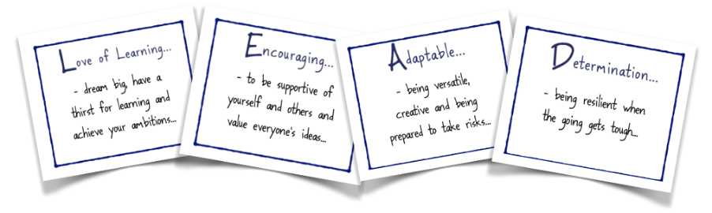

**Comic Relief**

Friday 18th March is our non-uniform day. Children can come to school in something red or wear fancy headgear. We are asking for donations of £1, which will be collected by the class teachers.

We will be selling red noses from the office all week at £1.50 each. All money raised will go to Comic Relief.

**Year 6 SATs**

Year 6 children will receive a separate letter about extra revision clubs in preparation for their upcoming SATs and information can also be found on the school website under [Classes > Y6](http://www.fulfen.staffs.sch.uk/class/year-6) at the bottom of the page. We encourage as many children as possible to attend the revision sessions and to make good use of the CPG revision books.

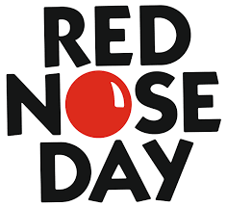

**New Library Grand Opening!**

The grand opening of our new library was a huge success and we are so pleased to see children beginning to loan out books. We gave a warm welcome to Natalie Pritchard who spent the day meeting our children and for those that wanted, the signing of her books. We felt a huge buzz around the school for the entire day and the excitement was displayed on the children’s faces. Darren Ennis and Diane Evans, who mirror our philosophy on the importance of reading, attended the opening too. They also spent some time answering questions for our school council.

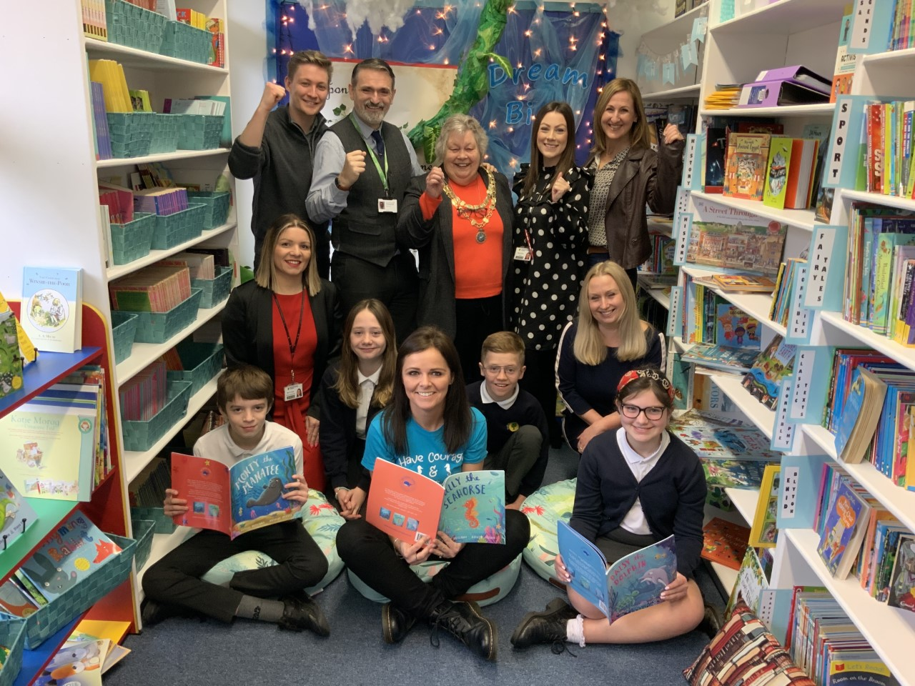 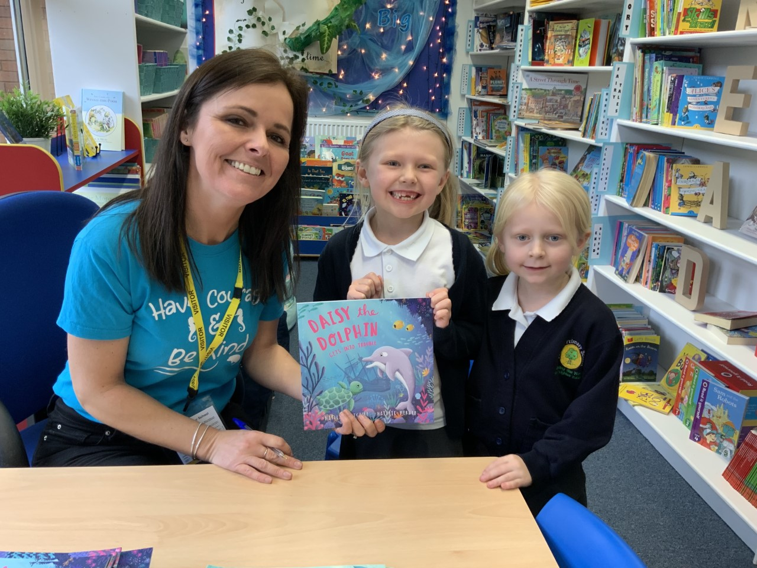

**Packington Farm Visits**

Nursery, Year 2 and Year 6 welcomed Packington Farm into school. They gave talks on healthy eating and farm animals. Nursery children were thrilled with their visit. Joules was accompanied by one of her chickens and they learnt all about her. Year 2 and Year 6 engaged in taste testing a rainbow of fruits and vegetables. The mangetout and pomegranate went down a treat! It was so wonderful to see our children trying new foods and so many of the children commented that they’d tried something new and really enjoyed it.

**World Book Day**

The participation in World Book Day this year was phenomenal. It was so wonderful to see the children dressed as their favourite book characters. Our children clearly love to read and enjoy making the most of this annual celebration of reading.

**Dates for your diary**

Friday 18th March – Comic Relief non-school uniform day

Tuesday 22nd March – Year 5 Trip to see Matilda at CTA

Wednesday 23rd March 23rd Year 2 Trip to Sealife Centre