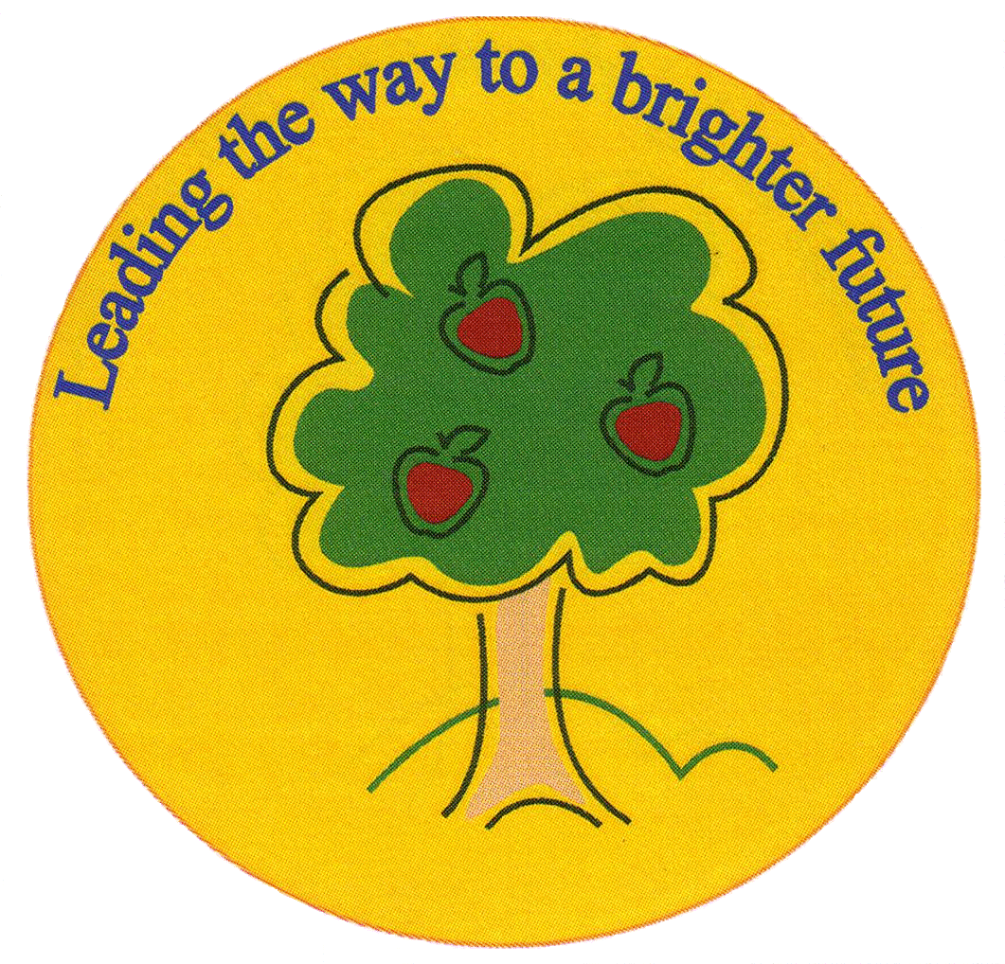
Fulfen Primary School

Rugeley Road
BURNTWOOD
Staffordshire
WS7 9BJ

Telephone: 01543 226070
E-mail: Office @fulfen.staffs.sch.uk

Headteacher: Miss Jane Davies

Dear parents/carers,
We have organised a trip for Year 1 to visit the Black Country Museum on Thursday 2nd April 2020

As part of our history topic ‘Changes within living memory- toys’ we will be learning all about toys from the past. Our trip to the museum will give the children an insight to what toys were used a long time ago and give them the opportunity to compare them to toys of now, whilst taking part in workshops about old toys.
We will be travelling by coach and will leave at 9:00 and return at 3:30pm.
Children are required to wear school uniform on the day. A packed lunch will be required. Please pack food and drink items in a plastic bag so that it can all be thrown away at the end of lunch. Please make sure you do not pack any items that contain nuts.

The cost of the trip will be £14.50 this includes admission, two workshops and transport cost for the coach.
If your child requires a freshly prepared packed lunch provided by school can you please make this clear on your reply slip and return it by Monday March 23rd 2020. Please complete and return the consent form, and pay for the trip via Parent Pay. Unfortunately, if we do not receive enough contributions, this trip will have to be cancelled.

Yours sincerely

Year 1 Team
__________________________________________________________________________________
Year 1- Black Country Museum – Thursday 2nd April 2020

Name of child: ____________________________ Class: _____________

I give permission for my child to attend the trip to the Black Country Museum.
I have paid a contribution of £14.50 via parent pay for this trip.

**** I will require a packed lunch from school for my child
(in which case, please return slip by Monday March 23rd in order for the kitchen to order food)****

Signed: __________________________ (person with parental responsibility)

