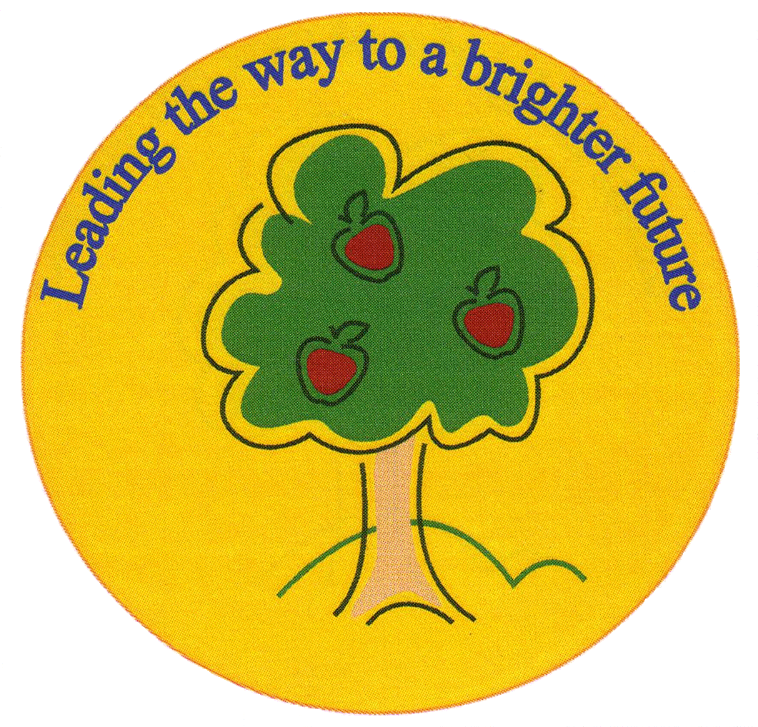
Fulfen Primary School

Rugeley Road
BURNTWOOD
Staffordshire
WS7 9BJ

Telephone: 01543 226070
E-mail: Office @fulfen.staffs.sch.uk

Headteacher: Miss Jane Davies Monday 3rd February 2020


Monday 10th February – Friday 14th February
Mind Awareness Week

Dear Parents/carers

From Monday 10th February we are having a week raising awareness for the charity ‘MIND’. We will be focusing on mental wellbeing and being happy.

There will be a whole school assembly on Wednesday 12th February and the children will be given leaflets that outline the work of MIND and the Mental Health Foundation. During lessons the teachers will focus on how to keep mentally healthy.

On Friday 14th February we will have a non uniform day at school when children can come dressed in warm comfortable home clothes. We are asking for a donation of £1 which will all go to the charity MIND.

Fulfen are very proud to announce that Juliet Davies who works in our school office is running two marathons in April, the London Marathon and the Manchester Marathon and is raising money for the charity MIND. If you would like to support her you can make a donation via her JustGiving page at https://www.justgiving.com/fundraising/juliet-davies11

If you have any questions regarding this week please contact us on 01543 226070. Thank you very much for your continued support.

Yours sincerely
Miss Jane Davies
Headteacher

re Mind, the mental health charity.
We won’t give up until everyone experiencing a mental health problem gets both support and respect.

