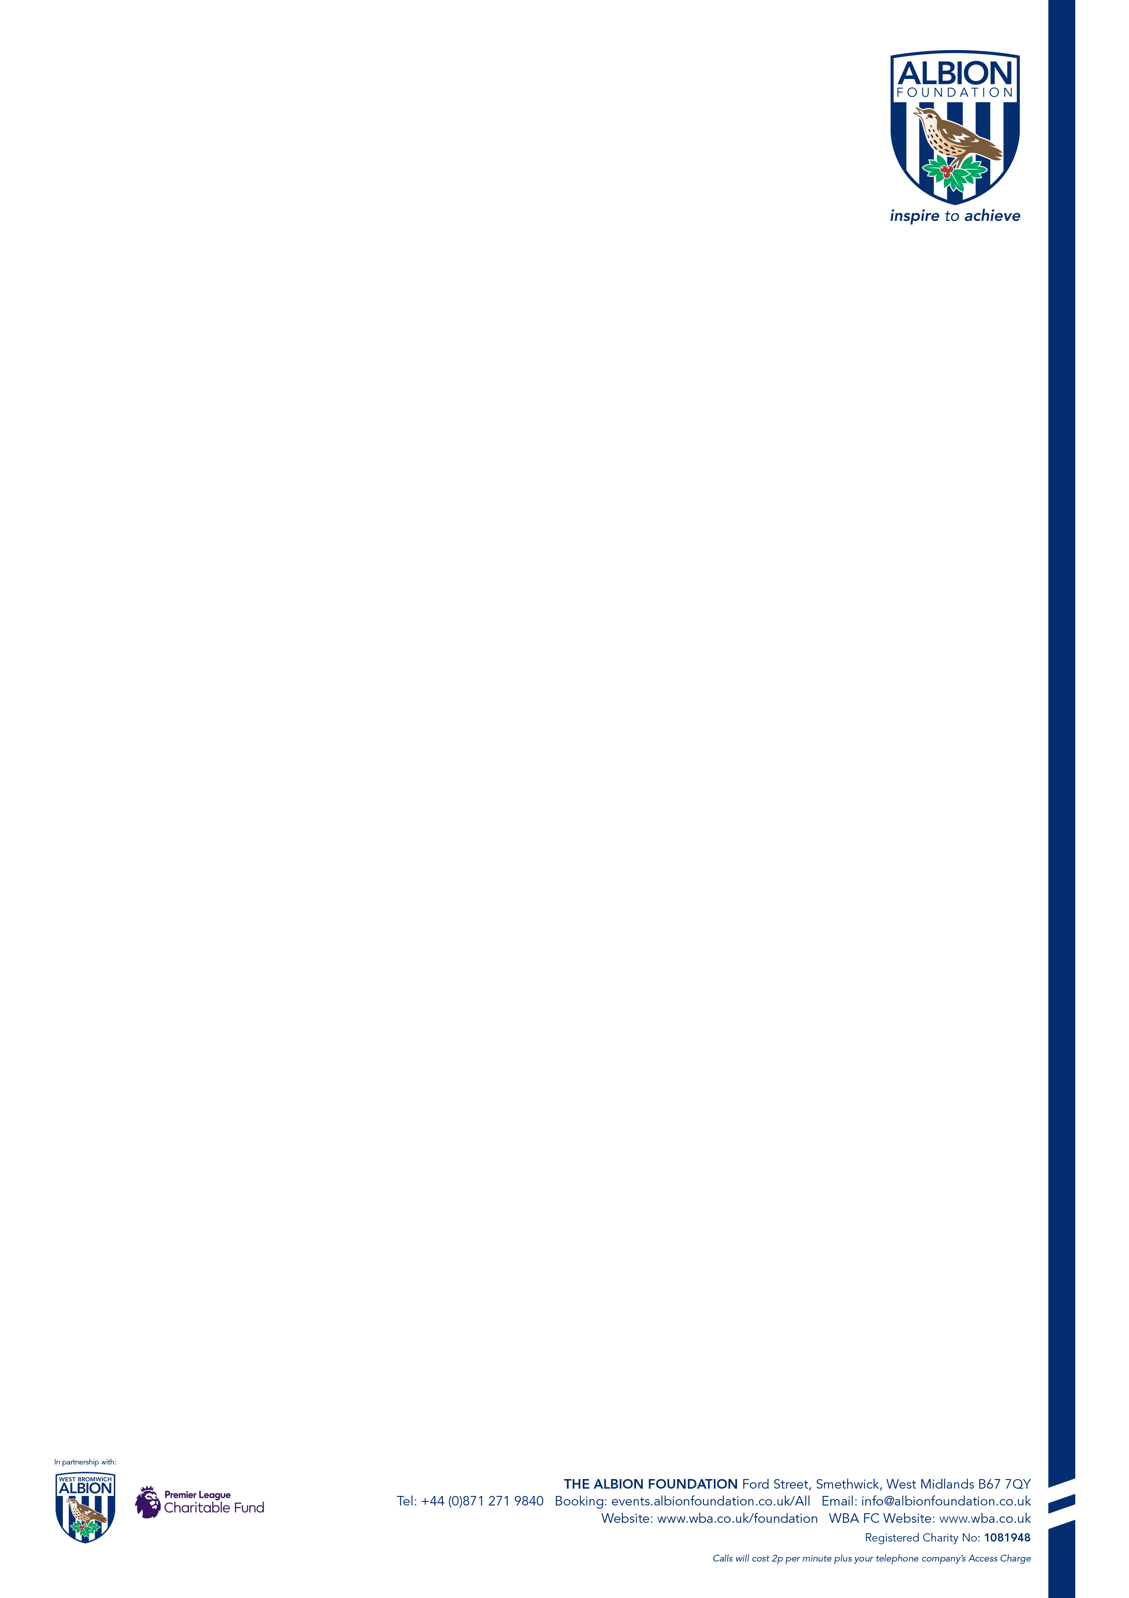
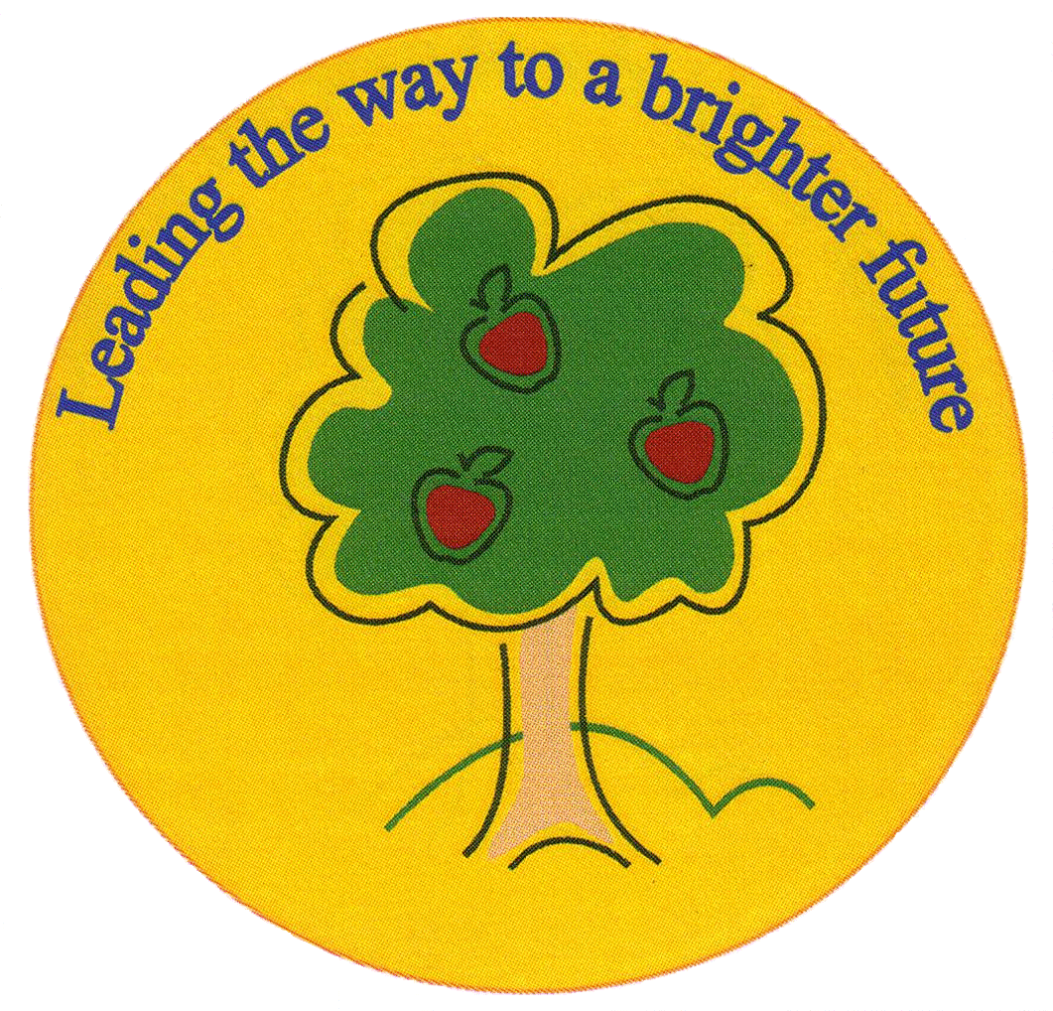30 July 2026
Fulfen Primary School
Headteacher: Miss Jane Davies

Dear Parent/Carer,

Beat the Baggies Bird- Fulfen Primary School

The Albion Foundation are inviting Fulfen Primary school students to take part in a ‘Beat the Bird Penalty Shoot Out’ fundraising activity, which will take place on 30th January.

To take part in this activity we ask that your child raises funds for The Albion Foundation, to be invested back into the local community and your school.

All Children will get a chance to participate and will be awarded with prizes based on how much money they raise.

Amount Raised | Prize
£3.00 - £10.00 | Certificate
£11.00 - £25.00 | Certificate and Cap
£26.00 - £30.00 | Certificate, Cap and Ball
£31.00 - £50.00 | Certificate, Cap, Ball and Camp Place
£51.00 - £99 | Certificate, Cap, Ball, Camp Place, and two tickets to a WBA home fixture
£100+ | Certificate, Cap, Ball, Camp Place, two tickets to a WBA home fixture and Mini Ground Tour on day of the fixture
Participant who raises the most money across all centres. | Certificate, Cap, Ball, Camp Place, two tickets to a WBA home fixture and Mini Ground Tour on day of the fixture + WBA Signed Shirt

Your child will be required to return their fundraising form by January 27th (see on the back) along with any money raised, before taking part in Beat the Bird.

Prizes will be distributed at a later date, yet to be confirmed.

Thank you,

The Albion Foundation

SPONSORSHIP FORM

I will be taking part in The Albion Foundation Beat The Bird Penalty Shoot Out Fundraiser to help raise funds for The Albion Foundation and Fulfen Primary School.

Name of Child: _______________________________________________
Name of School: _______________________________________________
Date of Fundraiser: ______Thursday 30th January 2020___________________

Name of Sponsor | Contact Details | Amount Donated | Amount Received

PRIZES I CAN WIN
£3.00 - £10.00 > Certificate £11.00 - £25.00 > Certificate & Cap
£26.00 - £30.00 > Certificate, Cap and Ball £31.00 - £50.00 > Certificate, Cap, Ball & Camp Place £51.00 - £99.00 > Certificate, Cap, Ball, Camp Place & Two Tickets for WBA Home Fixture £100 +> Certificate, Cap, Ball, Camp Place, Two Tickets for WBA Home Fixture & a ground tour Child who raises the most overall > Certificate, Cap, Ball, Camp Place, Two Tickets to a WBA Home Fixture, a ground tour & Signed WBA Shirt

