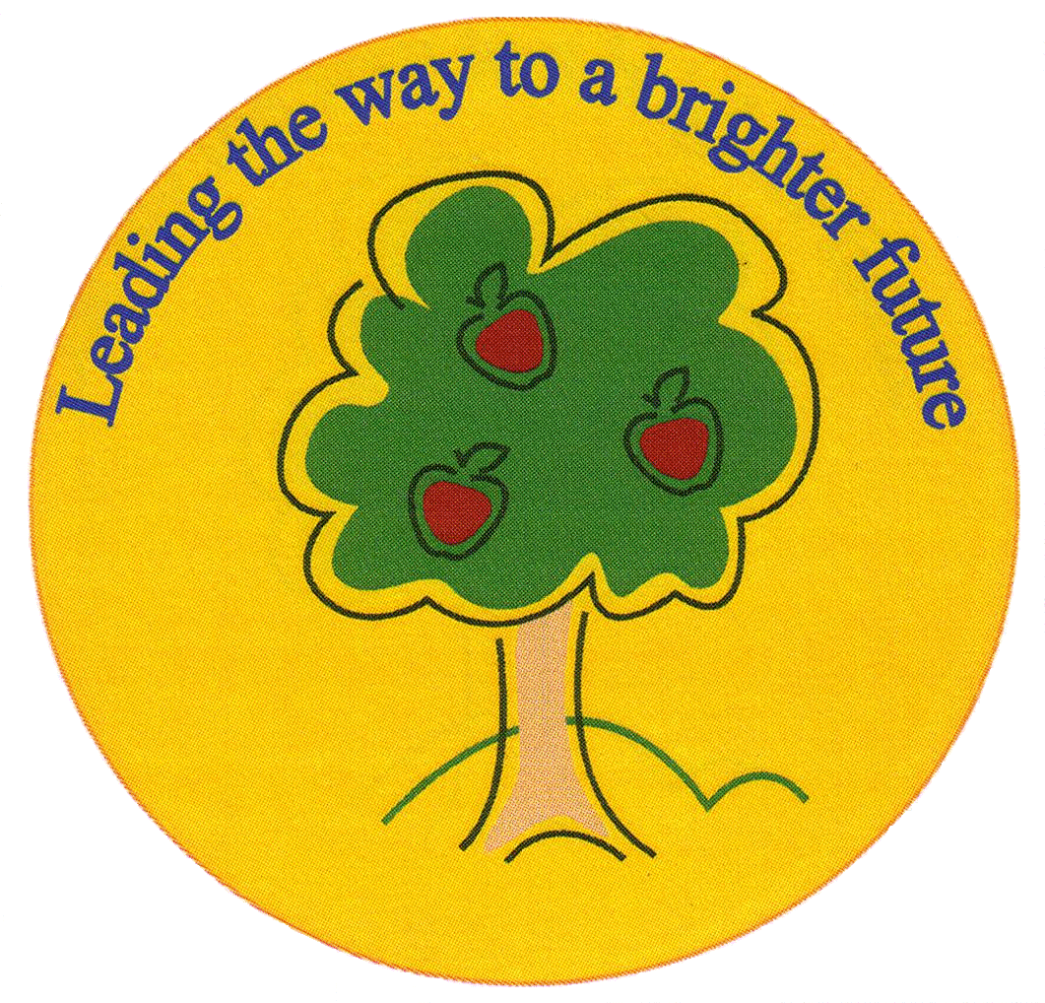
Fulfen Primary School

Rugeley Road
BURNTWOOD
Staffordshire
WS7 9BJ

Telephone: 01543 510400
Facsimile: 01543 510405
E-mail: Office@fulfen.staffs.sch.uk

Headteacher: Miss Jane Davies

Visit to the Weston Park for a WW2 experience day
Dear Parents/Carers,

As part of our WW2 topic, we have been learning about the impact of the war on Britain. Therefore, we have organised a trip to Weston Park on Tuesday 28th January 2020. Children will spend the day taking part in a range of different activities, such as, visiting an Anderson Shelter and experiencing a short black out/air raid experience.

Children will need to come to school at normal time and will return to school before the end of the school day. They will need to bring a packed lunch and a snack which we will eat at Weston Park. Please ensure that there are NO NUTS in any of the food that your child brings with them on the trip.

Children have the option to dress up as a World War Two evacuee to fully submerse themselves in the experience. However, if not, children should wear normal school uniform. All children need to bring a bottle of water (no fizzy drinks or squash). They may be outside for short periods of time so children should bring an outdoor coat.

We are asking for a contribution of £13.00 towards the cost of transport and a whole day of hands-on experiences led by trained staff. Children will not need any spending money as there will not be an opportunity to visit any shops. Although the contribution is voluntary, the trip may be cancelled if we do not receive sufficient funds.

Please complete the attached slip and return it to school as soon as possible. If you have any questions about this trip, please do not hesitate to contact us.

Yours sincerely,

Mr. Wood, Miss Gardner & Miss Green

Weston Park WW2 experience

I give permission for my child _________________________ in class _______________ to travel by coach to Weston Park on 28th January 2020. I have paid £13.00 on Parent Pay as a contribution to the cost of transport and admission to the museum.

I am in receipt of FSM and would like the kitchen to prepare a packed lunch.

Signed: ___________________________________________ Date: ______________

