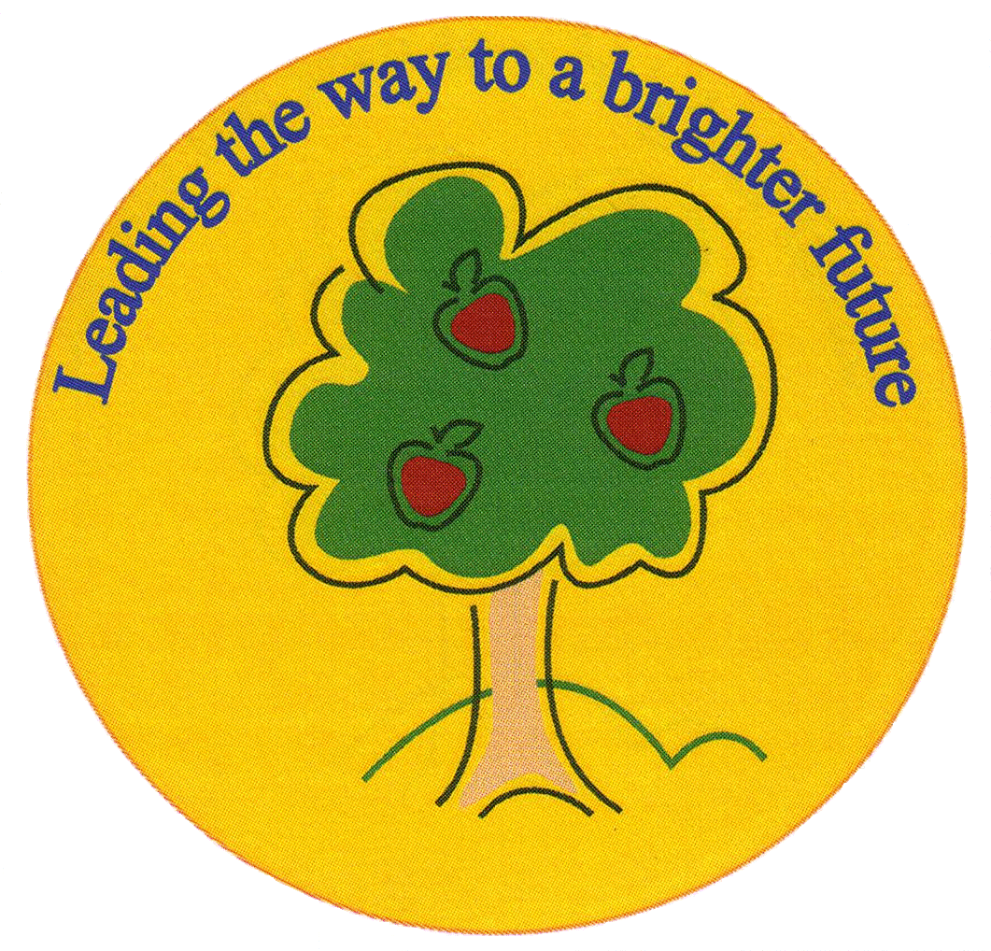
Fulfen Primary School

Rugeley Road
BURNTWOOD
Staffordshire
WS7 9BJ

Telephone: 01543 226070
E-mail: Office @fulfen.staffs.sch.uk

Headteacher: Miss Jane Davies


“Christmas Carol Concert”

Dear parent/carers
This Year our Year 6 children will be performing in a Christmas Carol Concert at Christ Church in Burntwood.

The concert will take place on Thursday 19th December at 7.00pm

There will be limited seats available in the church, so we will have to limit the tickets to two tickets per family. We regret that we will not be able to admit anyone, including children, without a ticket. Key Stage 1 children and Years 3, 4 & 5 children will be able to watch the dress rehearsal.
Please indicate below if you would like one or two tickets. The tickets will be issued on a first come first served basis, all requests to be received by Friday 6th December. The tickets will be issued week commencing 9th December.

Year 6 Staff
…………………………………………………………………………………………………………………………………………………………………….
Years 6 Christmas Carol Concert

Child’s name ______________________________Class__________

I would like one / two tickets for the concert on Thursday 19th December at 7.00pm

Signed: ______________________________________________ Parent/Guardian

