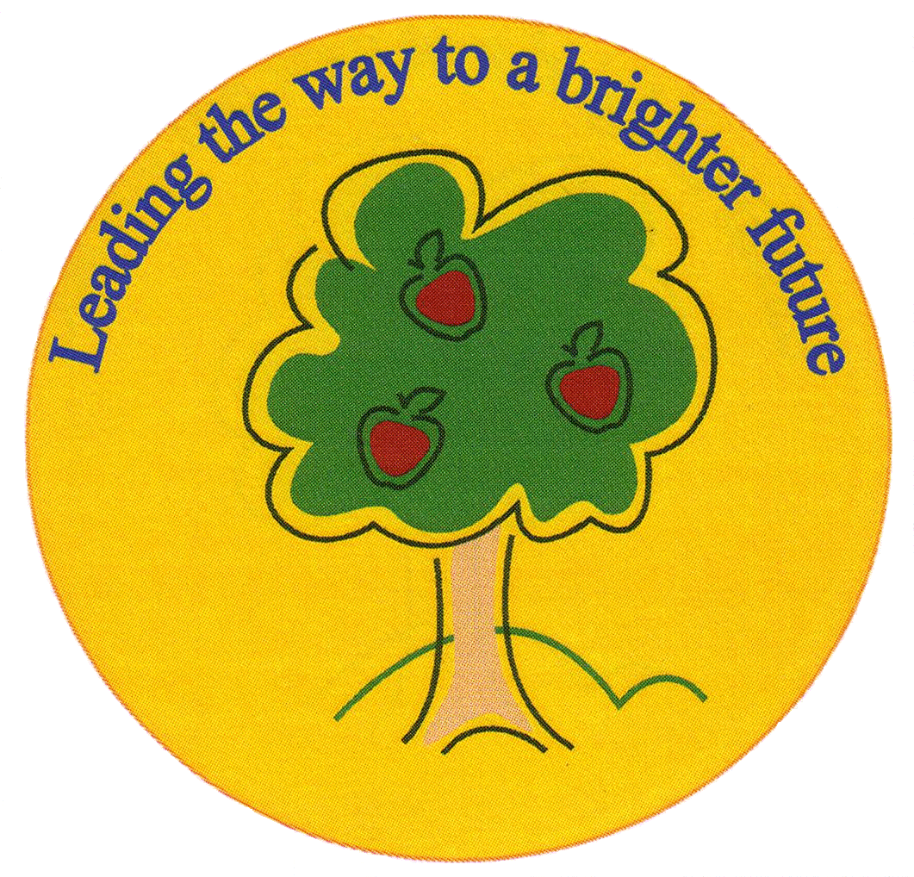
Fulfen Primary School

Rugeley Road
BURNTWOOD
Staffordshire
WS7 9BJ

Telephone: 01543 226070
E-mail: officer@fulfen.staffs.sch.uk

Headteacher: Miss Jane Davies

29th November 2019
Dear Parents/Carers

This year, Key Stage 1 will be performing “Born in a Barn” in the school hall on Monday 16th December at 2.30pm and Tuesday 17th December at 9.30am.
The Christmas celebration tends to be a very popular event, there are no tickets but we would ask if no more than two people attend each performance. Key Stage 2 children will be able to watch the Dress Rehearsal.
As you are aware, we are unable to offer any parking at school, and would politely remind you to consider our neighbours when parking outside school. After the performance on the 16th December, children will need to be collected from school at the normal time of 3.30pm.
Please complete and return the slip below to indicate which performance/s you and your family would like to attend.
Please could we have all costumes into school by Monday 9th December.

We look forward to welcoming you to our performance.

Yours sincerely

Key Stage 1 Staff

KS1 Christmas Production “Born in a Barn ”

Child’s Name: ……………………………………………………… Class:……………………………………………..
I/we wish to attend on Monday 16th December at 2.30pm. Please indicate number of seats required
I/we wish to attend on Tuesday 17th December at 9.30am. Please indicate number of seats required

