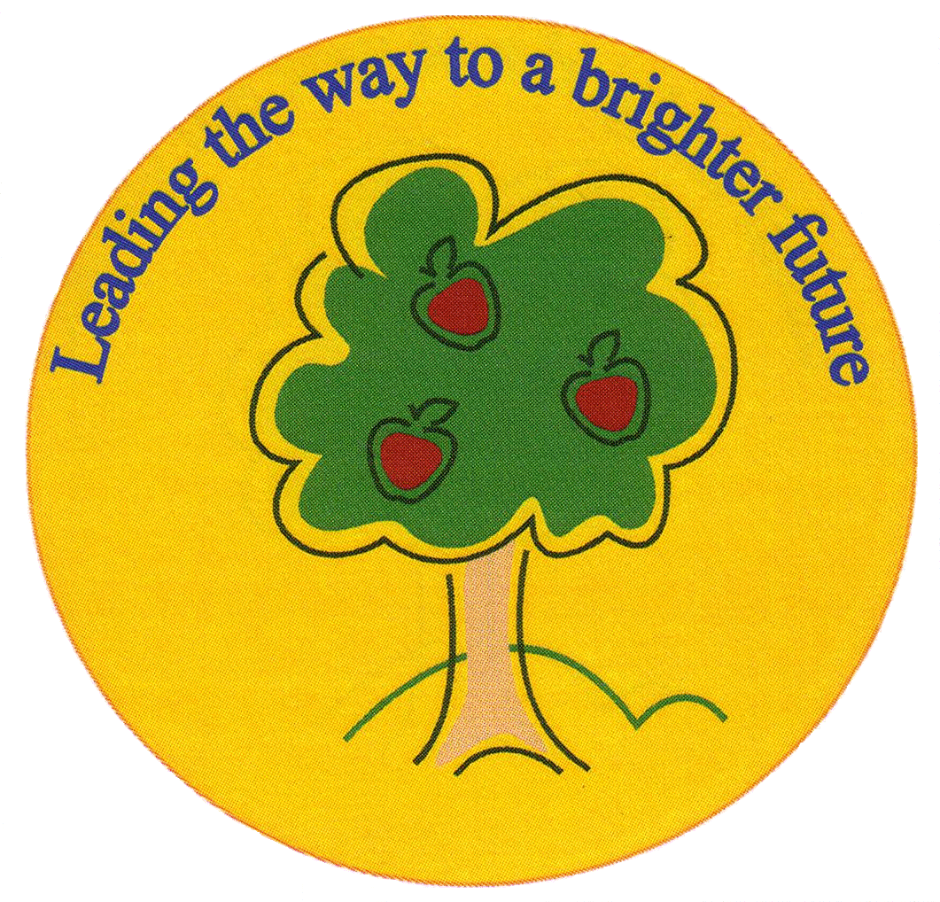
Fulfen Primary School

Rugeley Road
BURNTWOOD
Staffordshire
WS7 9BJ

Telephone: 01543 226070
E-mail: Office@fulfen.staffs.sch.uk

Headteacher: Miss Jane Davies

8th November 2019

Dear Parents,

We would like to invite you to an Early Years Reading workshop for parents on Tuesday 19th November at 3.30pm. It will last approximately 30 minutes. At the meeting we will tell you all about how your child will learn to read within school and provide information for you to help them at home. Research shows that when teachers and parents work together in this way children make the best possible progress.

We really hope you can join us for this essential meeting. Please complete and return the slip below to accept our invitation.

We look forward to seeing you there.

Kind Regards,

Miss Chapman
(Head of Early Years)

EYFS READING WORKSHOP ACCEPTANCE SLIP

Name of child: Class:

I will/will not* be attending the workshop for parents on Tuesday 19th November @ 3.30pm-4pm

Signed:

*Delete as applicable

