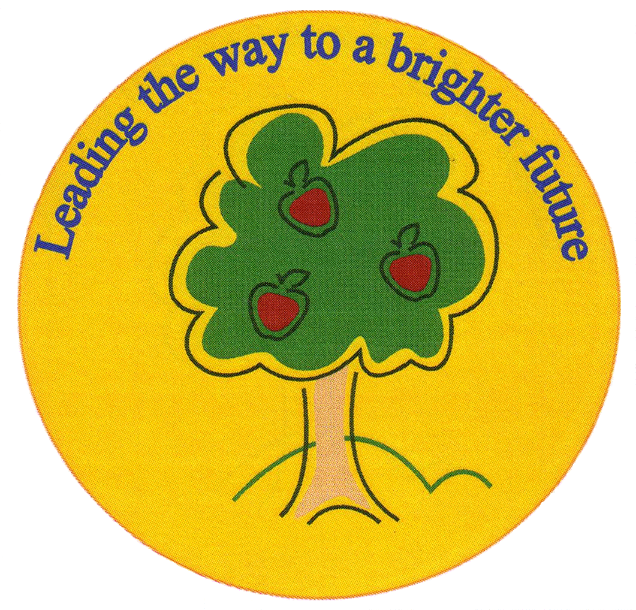
Fulfen Primary School

Rugeley Road
BURNTWOOD
Staffordshire
WS7 9BJ

Telephone: 01543 226070
E-mail: Office @fulfen.staffs.sch.uk

Headteacher: Miss Jane Davies

Dear Parents/Carers,

On Tuesday 12th November, Year 5 will be having a short activity morning in the Forest School in preparation for the new writing topic ‘Writing stories from different perspectives’.

For this activity, the children will require Forest School clothes. Could these please be brought to school in a bag for the children to change into during the day?

Suitable clothing should include:

- Wellies
- Waterproof coats and trousers
- Jumper/fleece
- Gloves
- Hat
- Scarf
- Any extra layers of clothing based on the weather.

This activity will include the children taking part in small drama activities where they retell classic fairy tales from different perspectives; fairy tale reading with a hot chocolate; clay modelling on trees based on the Little Red Riding Hood; and some small games suitable for Forest School.

I have been attending Forest School training on a weekly basis over the last six weeks, so I am experienced in leading groups of children in a Forest School environment. However, should you have any questions, or should your child be allergic to hot chocolate or marshmallows, please come and see myself or Mr Gleeson at your earliest convenience.

This should be a very exciting morning for the children that will undoubtedly engage them in this topic and provide a range of creative ideas for them to use in their writing.

Kind regards,
Mr Chapman, Mr Gleeson and Miss Connock

