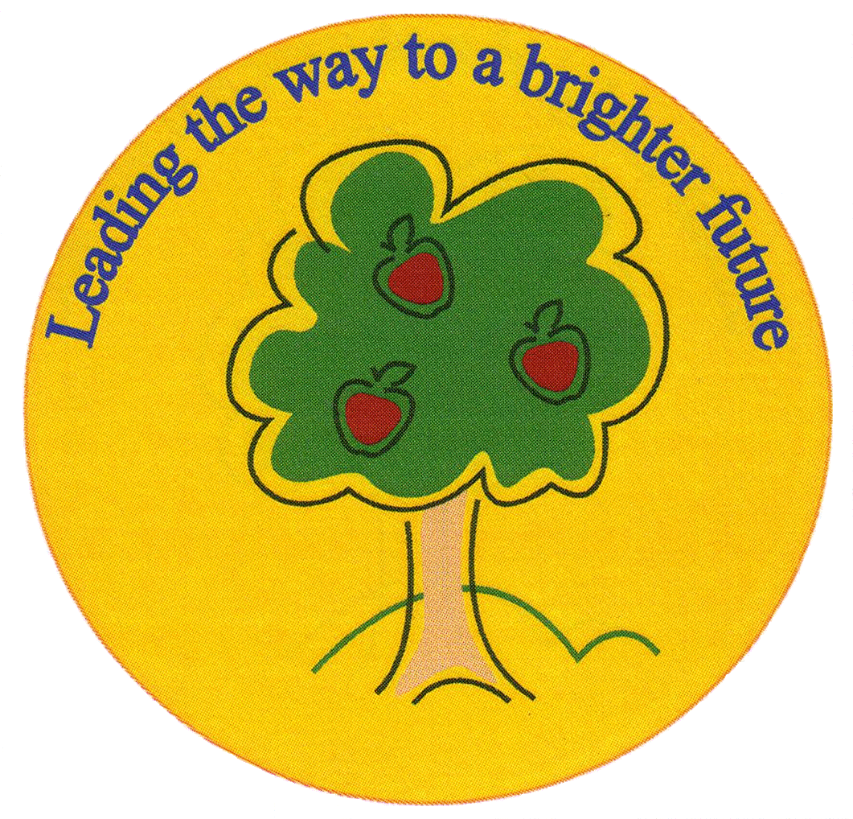
Fulfen Primary School
Rugeley Road
BURNTWOOD
Staffordshire
WS7 9BJ
Telephone: 01543 226070
E-mail: Office@fulfen.staffs.sch.uk

Headteacher: Miss Jane Davies

Dear Parents/Carers,

The school has updated its Safeguarding Policy in accordance with Staffordshire Local Authority guidance. The new policy can be found on the school website. There is a change in the policy this year in relation to the collection of children at the end of the day. The change is as follows:

- Children in Key Stage 2 may be collected by:
  - an adult with parental responsibility
  - a nominated (named) adult, provided written consent has been received from an adult with parental responsibility
  - a child of high school age, provided written consent has been received from an adult with parental responsibility

- Children in Years 5 and 6 may walk home on their own, provided written consent has been received from an adult with parental responsibility.
- Children in Key Stage 1 and EYFS must be collected by:
  - an adult with parental responsibility
  - a nominated (named) adult, provided written consent has been received from an adult with parental responsibility
N.B. Children in Key Stage 1 and EYFS cannot be collected by anyone under the age of 18

- In an emergency, verbal permission will be accepted from an adult with parental responsibility, for another nominated (named) appropriate person, as outlined above, to collect their child. The adult with parental responsibility must call the school office on 01543 226 070 to give this permission. The office will confirm the person's identity before agreeing to release the child.

For information about who has parental responsibility please visit https://www.gov.uk/parental-rights-responsibilities.

We will be formally introducing this change to the policy from Monday 14th October 2019 so that we can collate together the required written consent. Written consent must be given by an adult with parental responsibility. The consent must be signed and dated. Please also ensure that you write your child’s name and class on the form. Please complete a separate form for every child that you have in the school.

The changes have been made to help us to safeguard your children in the best way possible. From Monday 14th October, any children that do not have written consent to be collected by a person other than an adult with parental responsibility will not be released at the end of the day until an adult with parental responsibility can be contacted.

To support us in facilitating this policy, children in Key Stage 2 will be released on the Key Stage 2 playground from Monday 14th October. Please collect your children from the Key Stage 2 playground from this date.

Could you please complete the attached form to indicate your preferences for collection and return it to school as soon as possible. If you have any questions about this policy, please contact the school office.

Thank you for your continued support,
Miss Davies
Headteacher.

End of day consent form

Name of child: __________________________________ Class: _____________

