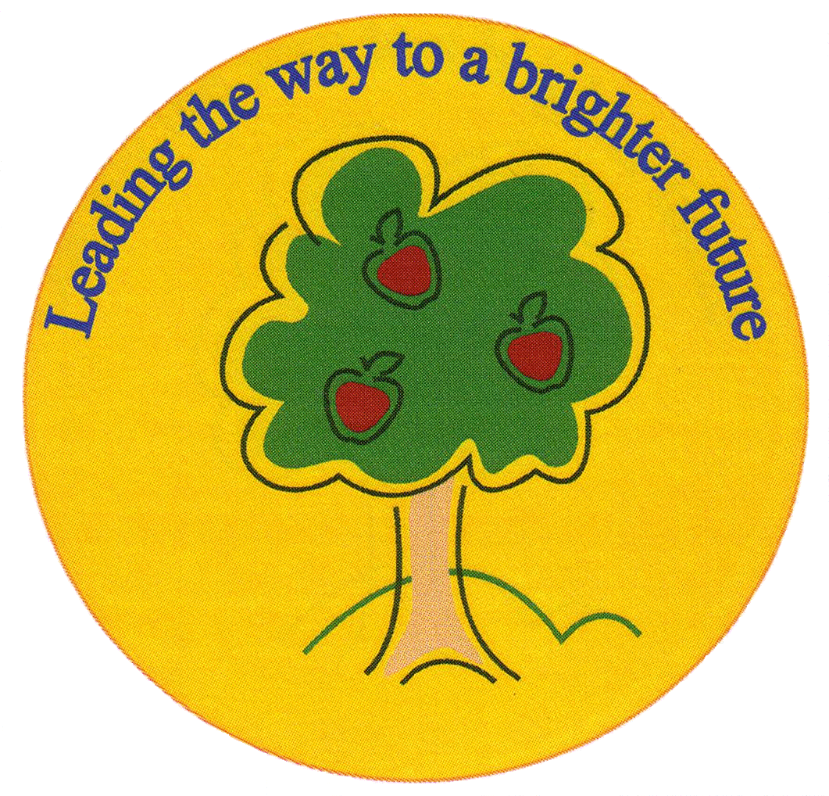
Fulfen Primary School

Rugeley Road
BURNTWOOD
Staffordshire
WS7 9BJ

Telephone: 01543 226070
E-mail: Office @fulfen.staffs.sch.uk

Headteacher: Miss Jane Davies

Dear Parents/Carers,
On Monday 21st October, Year 6 will be going to Chase Terrace Technology College to take part in a joint English and Reading project. The children will be working with high school English teachers and Year 7 and 8 pupils. This will be an opportunity for the children to experience life at high school, inspire them to produce some high quality, purposeful writing before and after the visit and finally enrich their reading skills through accessing and working within different parameters.
We will be walking to Chase Terrace after lunch at school and we will be returning by the end of the school day. There is no charge for this trip. Children must ensure they have their inhalers with them, if needed, and they bring a coat with them that day.
As part of this exciting project, the staff at CTTC have asked if we they can take photographs of the children to put on their website.
Please return the permission slip by Thursday 17th October.
Thank you and best wishes,
Mr Wood and Miss Gardner
……………………………………………………………………………………………………………………………………………………………………

I give permission for _________________ (child’s name) ________(Class)to visit CTTC on 21st October 2019

I give/don’t give permission for _____________(child’s name) to have their photograph taken and put on the website of CTTC.

Signed _____________________________ (parent/carer signature)

