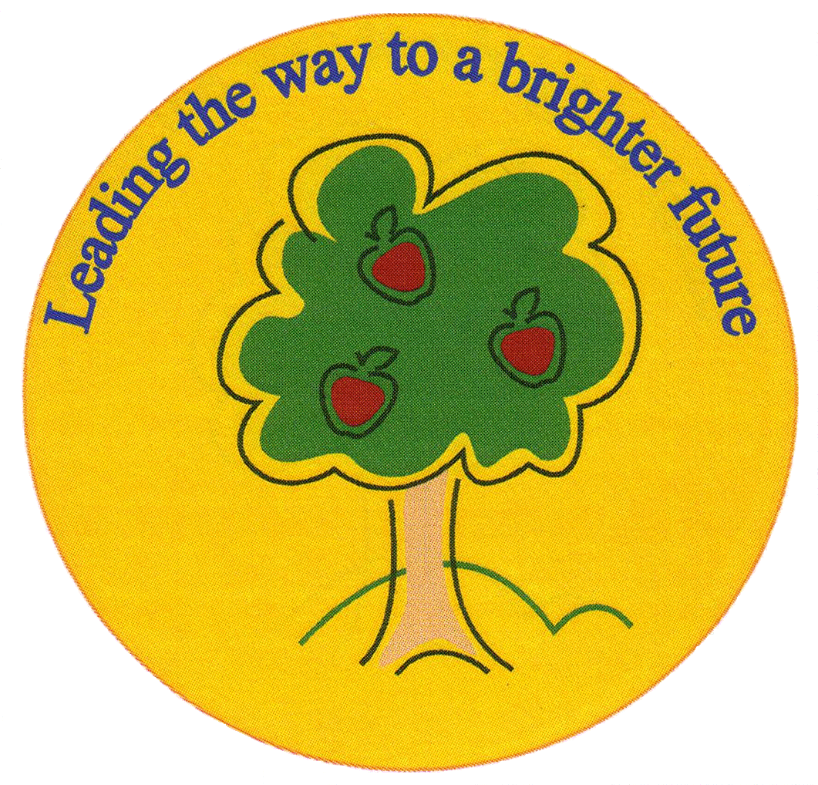
Fulfen Primary School

Rugeley Road
BURNTWOOD
Staffordshire
WS7 9BJ

Telephone: 01543 226070
E-mail: Office @fulfen.staffs.sch.uk

Headteacher: Miss Jane Davies

Dear Parents/Carers,

In preparation for our trip to the Harry Potter studios, the year 6 team will be running an after school ‘Year 6 film club’ in order to provide the children with the opportunity to watch some of the ‘Harry Potter’ films with their friends before the trip.

We will be running the club on the week commencing the 4th November for 4 weeks from 3:30pm – 5:00pm on a Monday evening. The dates for each club are as follows:

Monday 4th November, Monday 11th November, Monday 18th November and Monday 25th November

The children are more than welcome to bring with them snacks and drinks to enjoy during the film but this is not essential.

As some of you may also be aware, the first 3 Harry Potter films (that we will be showing) have an age rating of PG. So by granting your permission to attend the film club we will also need your permission for your child to view PG films. Please complete the permission slip below.

Thank you for your continued support

Miss Gardner, Mr Wood & Miss Green
……………………………………………………………………………………………………………………………………………………………………………………
Year 6 film club

I give permission for my child……………………………………………………………………………… Class…………………..

To attend the Year 6 film club on the 4th, 11th, 18th and 25th November 2109.

I also give permission for my child……………………………………………………………………………… Class…………………..
to view PG age rated films.

