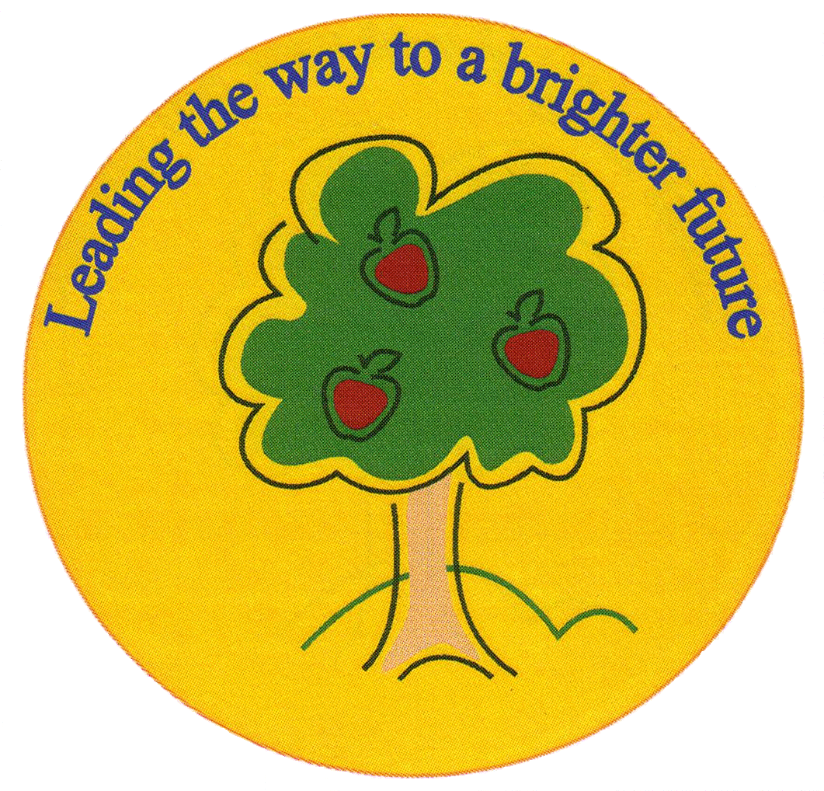
Fulfen Primary School

Rugeley Road
BURNTWOOD
Staffordshire
WS7 9BJ

Telephone: 01543 226070
E-mail: Office@fulfen.staffs.sch.uk

Headteacher: Miss Jane Davies

Dear Parents/Carers

Year 5 have been invited to Burntwood Library to take part in an educational experience, which aims to engage and motivate all pupils to read a variety of non-fiction and fiction texts.

The trip will take place on Friday 4th October. We will walk with the classes at 1:15pm to arrive for 2pm and leave at 2:50pm to arrive back for the end of the day.

There is no fee for this trip as we are planning to walk to the library.Please ensure your child wears appropriate footwear and has a coat with them.

We hope these sessions will be a fun and informative experience for the children. Please complete the permission slip and the library joining form as soon as possible.

Thank you for your continued support.

Mr Chapman & Mr Gleeson
……………………………………………………………………………………………………………………………………………………………………………….
Burntwood Library Trip

Child’s name…………………………………………………………………Class…………………………..

I give/do not give permission for my child to attend Burntwood Library.

Signed……………………………………………………………….. Date……………………………………

