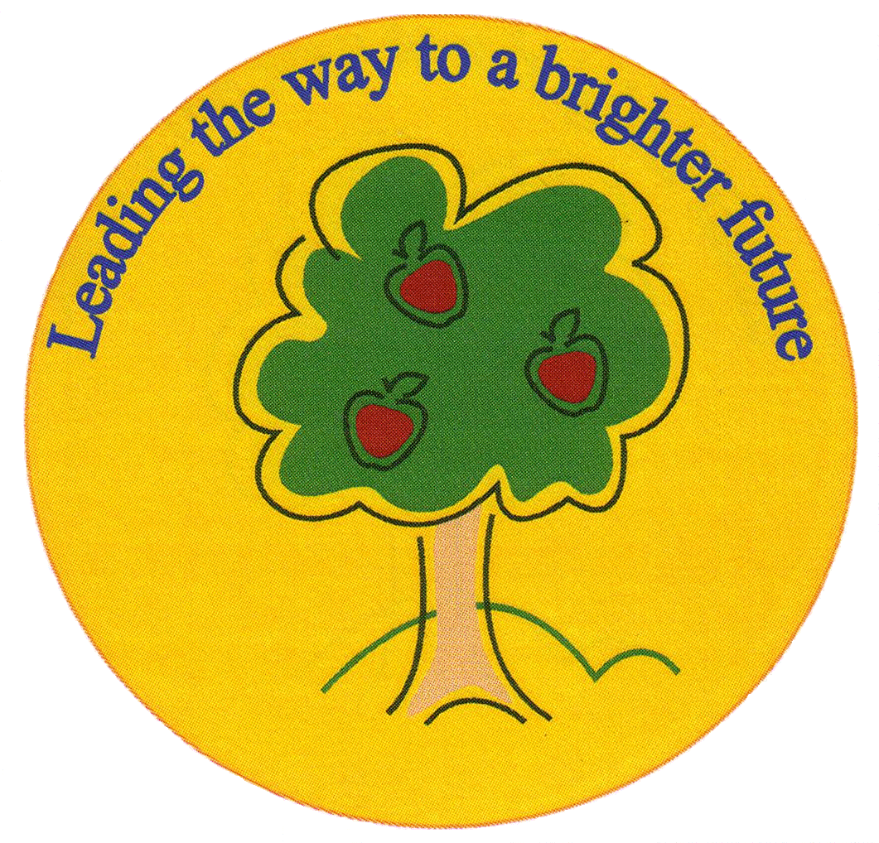
Fulfen Primary School

Rugeley Road
BURNTWOOD
Staffordshire
WS7 9BJ

Telephone: 01543 226070
E-mail: Office @fulfen.staffs.sch.uk

Headteacher: Miss Jane Davies

Dear Parents/Carers,

On Monday 7th October, Year 6 will be visiting Birmingham Central Mosque as part of our topic on Ancient Islamic civilisation. This visit will offer the children a fantastic opportunity to see first-hand the structures & features of a mosque as well as the daily worship practised by Muslims.

We will be leaving school at 9.15am to arrive at the mosque at approximately 10.00am. We will be given a guided tour during which the children will be allowed to ask questions and observe a special prayer service.

Children will wear their normal school uniform and will be back in school in time for their school dinner as normal. Children can be collected at the normal time.

A voluntary contribution of £6.00 towards the cost of this visit would be appreciated. Please can you fill in the consent form and pay for the trip on Parent Pay before Friday 27th September 2019.

Thank you

Mr Wood & Miss Gardner
……………………………………………………………………………………………………………………………………………………………………………………
Visit to Birmingham Central Mosque

I give permission for my child……………………………………………………………………………… Class…………………..
To participate in the trip to Birmingham Central Mosque on Monday 7th October 2019.

I have paid £………………………… Voluntary contribution on Parent pay

Signed……………………………………………………………………………… Parent/Carer

