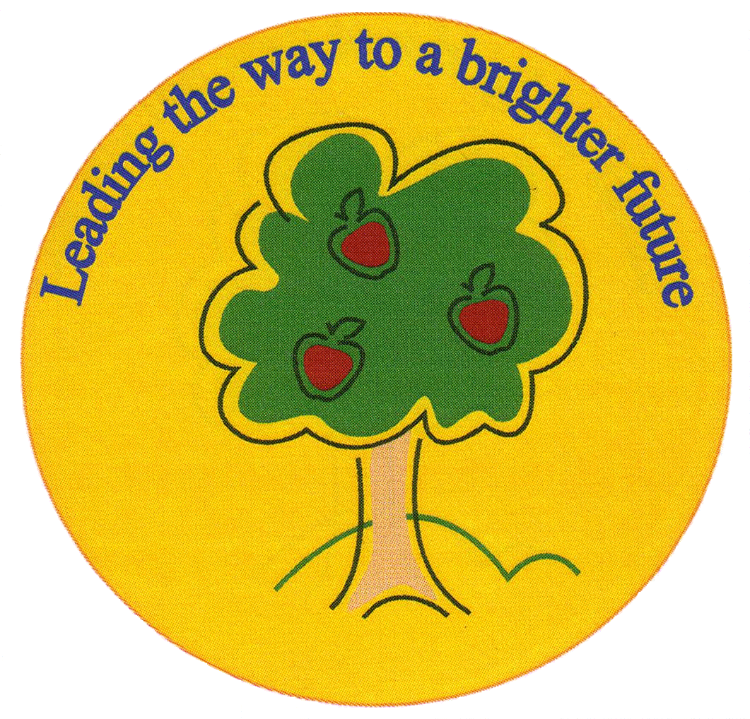
Fulfen Primary School

Rugeley Road
BURNTWOOD
Staffordshire
WS7 9BJ

Telephone: 01543 226070
E-mail: Office@fulfen.staffs.sch.uk

Headteacher: Miss Jane Davies

Dear Parents/Carers

Year 4 have been invited to Burntwood Library to take part in an educational experience, which aims to engage and motivate all pupils to read a variety of non-fiction and fiction texts.

The trip will take place on Friday 25th October 2019. Mrs Shermer (4S) will walk with her class at 9.00am and return to school in time for lunch and Miss Bate (4B) will walk her class at 10.00am and return to school in time for lunch. It will be non-uniform day on Friday 25th October, so the children can still come to school in home clothes but please ensure your child wears appropriate footwear and has a coat with them.

There is no fee for this trip as we are planning to walk to the library. Please ensure your child wears appropriate footwear and has a coat with them.

We hope these sessions will be a fun and informative experience for the children. Please complete the permission slip and the library joining form by Friday 11th October 2019.

Thank you for your continued support.

Miss Bate & Mrs Shermer
……………………………………………………………………………………………………………………………………………………………………………….
Burntwood Library Trip

Child’s name…………………………………………………………………Class…………………………..

I give/do not give permission for my child to attend Burntwood Library on Friday October 25th 2019

Signed……………………………………………………………….. Date……………………………………

