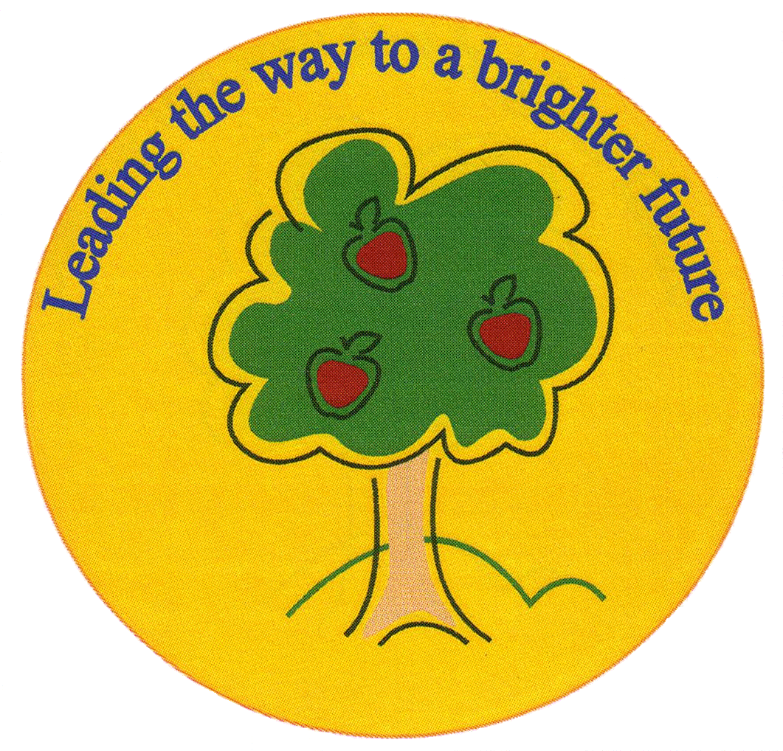
Fulfen Primary School

Rugeley Road
BURNTWOOD
Staffordshire
WS7 9BJ

Telephone: 01543 226070
E-mail: Office @fulfen.staffs.sch.uk

Headteacher: Miss Jane Davies

September 2019

Dear Parents/Carers,

On Tuesday 26th November 2019, Year 6 (for the first time ever) will be visiting the spectacular Harry Potter Studios as part of our English topic where we are using Harry Potter and the Philosophers stone as our stimulus. This visit will offer the children a fantastic opportunity to experience first-hand the making and props used to create the award winning films.

We will be leaving school at 9.30am to arrive at the studios at approximately 12:00pm. We will explore the studios, visit the Great Hall, fly on a broomstick and watch demonstrations throughout the day!

Children will also have the opportunity to visit The Backlot Café to enjoy a frothy Butterbeer; a non-alcoholic beverage reminiscent of shortbread and butterscotch, available in a souvenir tankard. This is optional with an additional cost of:
- £4.95 – just Butterbeer
- £6.95 – Butterbeer with souvenir tankard
*** If you are interested, please complete and return the ‘Butterbeer’ the slip below. ***
(We’re not trying to plug this, it is simply something they offer and a pre-booking for school visits is essential – this is at your discretion).

Children will wear their normal school uniform and because of the distance we are travelling and the time we will be back, your child will need to bring a packed lunch and a packed dinner/tea (2 packed lunches). We will be departing the studios at the latest 6:30pm, meaning we will be back to school between 8:30pm – 9:00pm. We will keep you updated on the day via text, our website and Twitter.

If your child is in receipt of Frees School Meals please can you indicate on the attached slip so that we can arrange for the kitchen to prepare two packed lunches for you.

We are asking for a voluntary contribution of £31.00 towards the cost of entry to the studios and the coach. We are aware that this trip is costly, therefore we will be offering payment instalments over September and October to spread out the cost should you wish too. In addition, the Year 6 team will be running after school movie nights offering the children the chance to watch some of the Harry Potter films before the trip. This will be at no further cost – more information about this will follow.

Please can you fill in the consent form and pay for the trip on Parent Pay before Friday 8th November. Unfortunately, if we do not receive sufficient voluntary contributions by 8th November, we will have to cancel this unique trip.

Thank you

Mr Wood, Miss Gardner and Miss Green
……………………………………………………………………………………………………………………………………………………………………………………
Visit to Harry Potter Studios

I give permission for my child……………………………………………………………………………… Class…………………..

To participate in the trip to Harry Potter Studios on Tuesday 26th November 2019.

I have paid £………………………… Voluntary contribution on Parent pay

I am in receipt of FSM and would like the kitchen to prepare 2 packed lunches.

Signed……………………………………………………………………………… Parent/Carer
…………………………………………………………………………………………………………………………………………………………………………………
Butterbeer tasting

I give permission for my child……………………………………………………………………………… Class…………………..

To participate in the Butterbeer tasting experience on Tuesday 26th November 2019.

Please make clear the option you would like.

I have paid

£4.95

£6.95 Voluntary contribution on Parent pay

Signed……………………………………………………………………………… Parent/Carer

