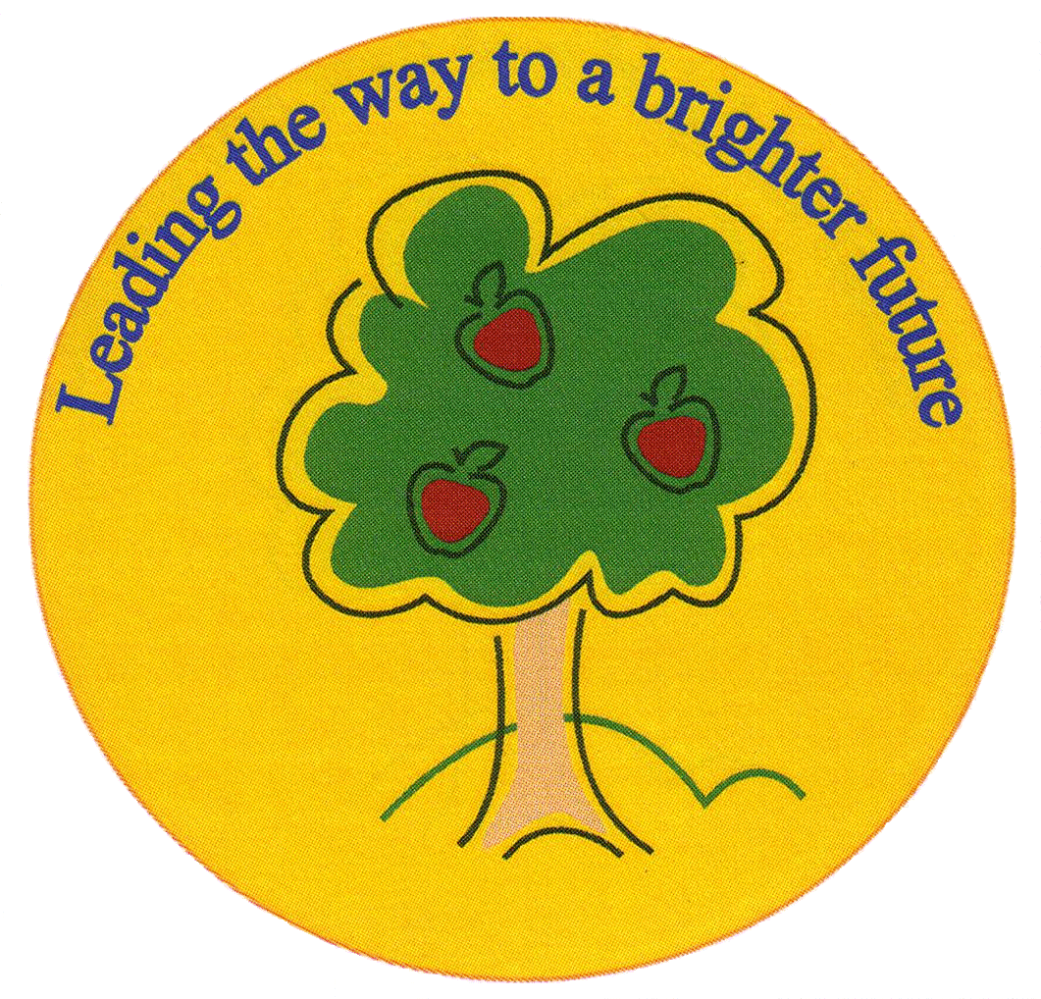
Fulfen Primary School

Rugeley Road
BURNTWOOD
Staffordshire
WS7 9BJ
Telephone: 01543 226070
E-mail: Office@fulfen.staffs.sch.uk

Headteacher: Miss Jane Davies 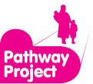
Harvest Festival

Tuesday 9th October

Dear Parents/Carers

Wednesday 16th October 2019
For Harvest Festival this year, we are supporting Pathway Project which are based in Lichfield and Tamworth.

Pathway Project works to support adults, young people and children, who are experiencing or affected by domestic abuse. Pathway aim to provide a range of high quality services., meeting the needs of abused adults and children, in a caring environment.

Fulfen Primary School have agreed to support this charity and we are asking for non-perishable food items, especially food in tins & packets. Children can bring in one item or several items. All the food will be on display in our reception area before it is collected on Friday 18th October.

We do hope you can join us for the harvest festival performances on Wednesday 16th October:-

KEY STAGE 2 9.10am – 10.00am

KEY STAGE 1 & RECEPTION 10.30am – 11.15am
You are welcome to Join us for a cup of tea and a biscuit before the performance.
If you would like more information about Pathway Project and the work they do please look at their website www.pathway-project.co.uk

Yours sincerely
Jane Davies
Headteacher

