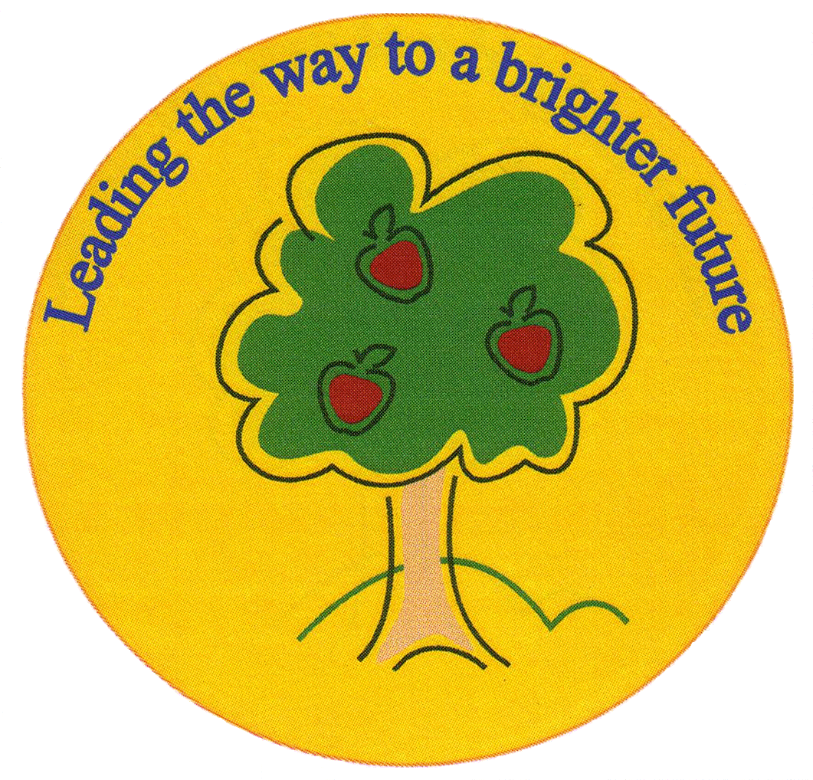
Fulfen Primary School

Rugeley Road
BURNTWOOD
Staffordshire
WS7 9BJ

Telephone: 01543 226070
E-mail: Office@fulfen.staffs.sch.uk

Headteacher: Miss Jane Davies

Dear parents,
As part of our Topic this term, we would like our children to participate in an Astronaut Training Day on the 10th September. Children will find out what it's really like to train to become an astronaut by completing activities designed by NASA to develop their speed, reaction times, dexterity, strength, agility and co-ordination, as well as improving their communication and problem solving skills. These are all skills that are essential for astronauts.
We will also be making some astronaut pudding just like the real astronauts eat when in space! Please can you let us know if your child has any food allergies we need to be aware of.
Please could all children arrive in sports clothes on this day in order to participate fully in the activities - trainers, joggers or shorts and t-shirt etc. Please could you also ensure your child brings a water bottle with them.

Thank you for your co-operation,
Mr Gleeson & Mr Chapman (The Year 5 Team)

