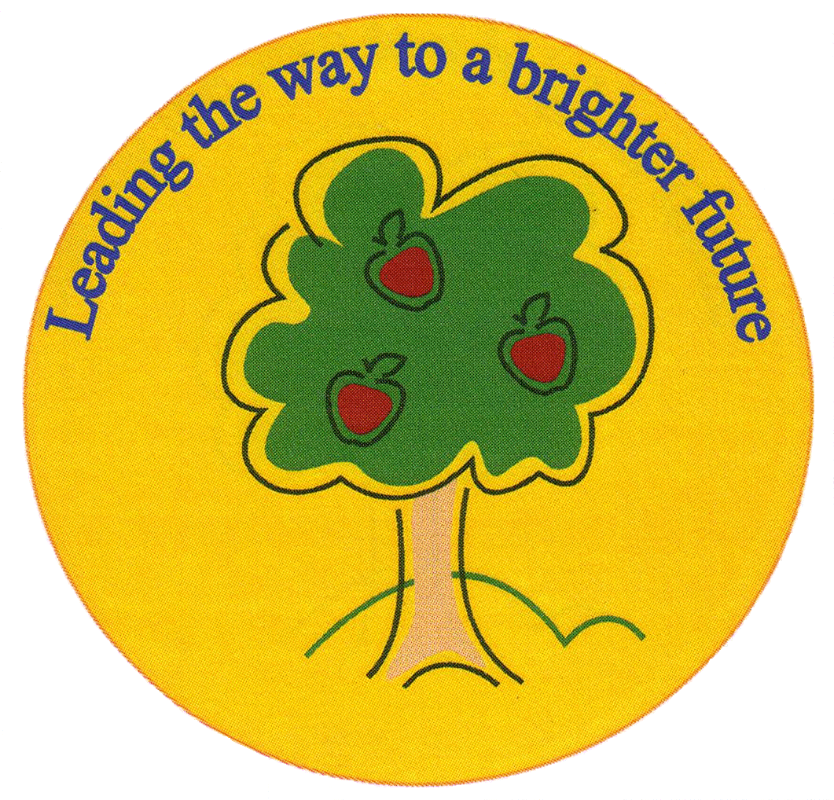
Fulfen Primary School

Rugeley Road
BURNTWOOD
Staffordshire
WS7 9BJ

Telephone: 01543 226070
E-mail: office@fulfen.staffs.sch.uk

Headteacher: Miss Jane Davies


Time to Get Baking
Reception & Nursery

Fulfen Primary school is proud to announce that we will be supporting the MacMillan “World’s Biggest Coffee Morning” again this year on:-

Friday 27th September 2019

We are asking for donations of shop cakes and cookies to be brought into school during the week commencing 23rd September. Any homemade cakes can be brought into school from Thursday morning.

We would like to invite you, your relatives, neighbours and friends to join us for a cup of coffee/tea and a cake from 8.15am – 9.30am on Friday 27th September. Children can also join you but must go to their classrooms when the bell goes at 9.00am.

Our Year 6 children are helping to organise this event, please come along and support them, last year we raised a staggering £ 550.00! Every penny will be donated to this worthwhile cause.
“Cakes Taste Better Together”.
Yours sincerely

Miss Jane Davies
Headteacher

