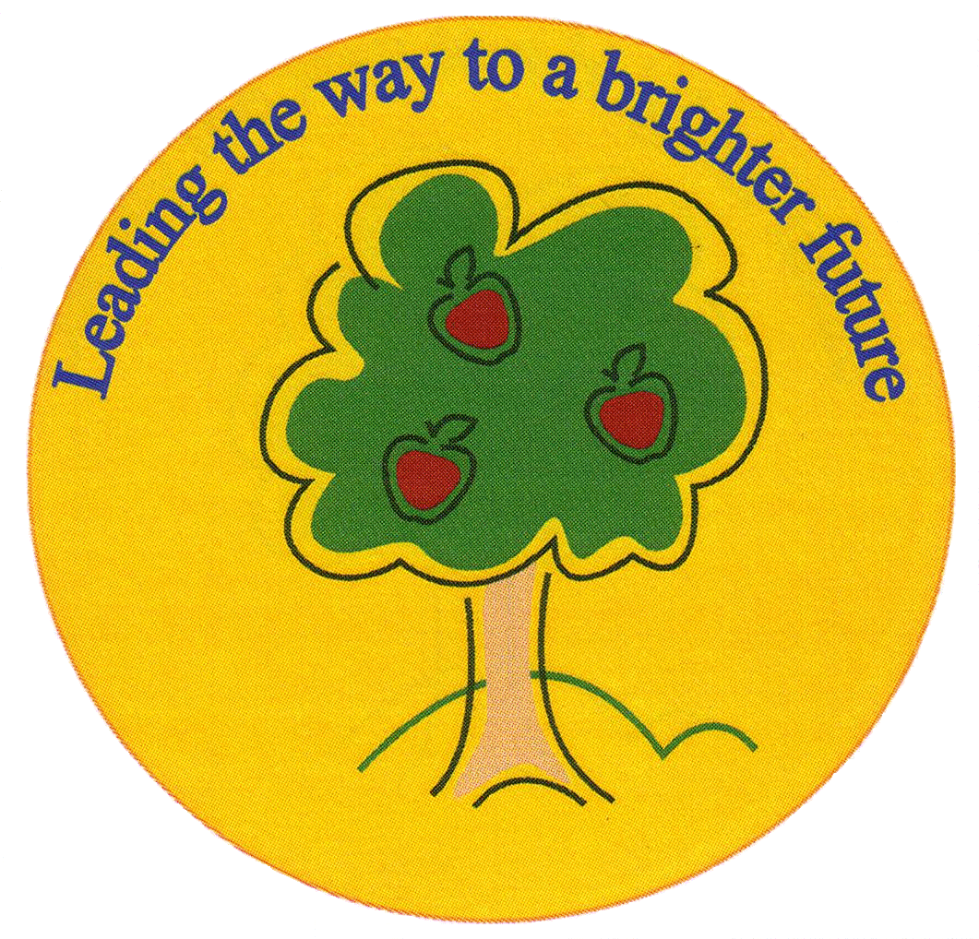
Fulfen Primary School

Rugeley Road
BURNTWOOD
Staffordshire
WS7 9BJ

Telephone: 01543 226070
E-mail: Office @fulfen.staffs.sch.uk

Headteacher: Miss Jane Davies
4th September 2019
Dear Parents/Carers

Snack
Children in years 1 to 6 can buy snack at morning playtime from the school kitcn. The following items are available:

Toast 30p Fruit 40p
Teacake 35p Milkshake 60p
Crumpet 30p Milk 30p
Bacon Roll (Tuesday only) 80p

Please note we do not have the facility to give change so your child must bring in the exact change for the items they want each day.

Please note that free fruit is still provided and that children are welcome to bring their own snack into school if you don’t want to pay for school snack.

Meet the Teacher Evenings
During the next two weeks, we are holding some Meet the Teacher evenings. These evenings are a chance for you to come into school, find out key information and dates for the year group and to discuss how you can support your child’s learning at home. You will also have a chance to have a look around the classrooms and ask any questions.
The meetings will start at 6.00pm with a short presentation by the year teachers and last for about an hour.

Important - The meetings are for parent/carers only as we do not have the facilities to supervise children on these evenings.

The dates for each year group are listed below. If you have any queries please do not hesitate to contact us.

Date | Year Group | Time
Tuesday September 10th | Year 4 | 6.00pm
Wednesday September 11th | Year 5 | 6.00pm
Thursday September 12th | Year 6 | 6.00pm
Tuesday September 17th | Year 3 | 6.00pm
Wednesday September 18th | Year 2 | 6.00pm
Thursday September 19th | Year 1 | 6.00pm
Tuesday September 24th | EYFS | 6.00pm

