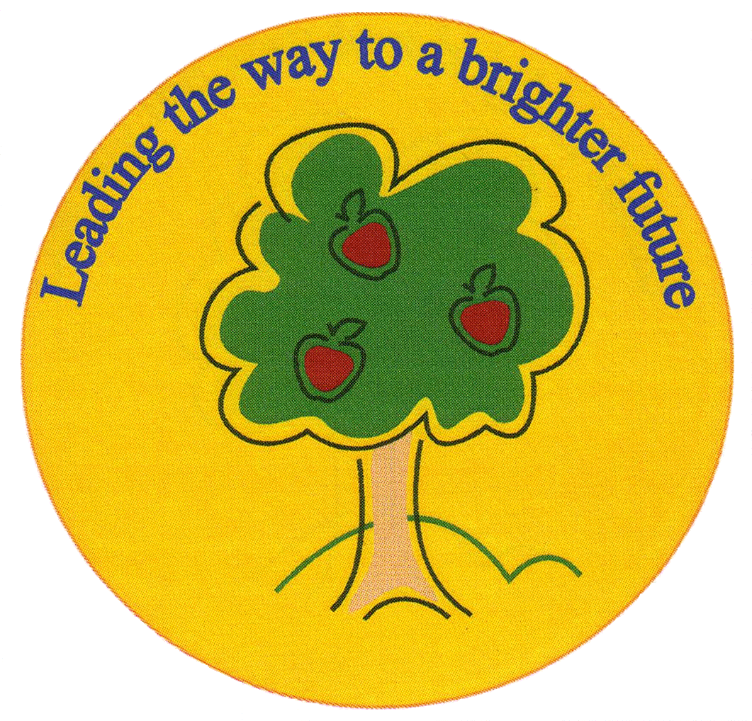
Fulfen Primary School

Rugeley Road
BURNTWOOD
Staffordshire
WS7 9BJ

Telephone: 01543 226070
E-mail: Office @fulfen.staffs.sch.uk

Headteacher: Miss Jane Davies

Dear Parents/Carers,

As you may be aware, our brilliant Brazilian topic will be coming to an end of this half term in order to make way for our new topic ‘Roman Britain’ in the Summer term.

We have thoroughly enjoyed all of the activities related to Brazil and would like to share an afternoon of topic with you through a Salsa making session!
Therefore, we would like to invite you to come into school and help your son/daughter make their own salsa on Wednesday 27th March 2019 at 2pm – 3pm. Please complete the detachable slip below.

We would be grateful if the children could bring the following ingredients with them and of course they will be able to take their salsa home for all the family to enjoy!
- 4 large tomatoes - 1 small, red onion
- 1 pepper (any colour) - 1 lime (optional)
- Plastic container with lid - an old t-shirt (optional for tomato stains!)
Olive oil and herbs will be available to add.

We appreciate your continuing support and are very much looking forward to seeing you at school. Please do not hesitate to contact a member of the Year 4 team should you have any questions regarding the salsa making afternoon.

Many thanks,

Miss Gardner, Mr Wood and Miss Atkinson.

Salsa Making Afternoon on Wednesday 27th March 2019 at 2pm
Name of child: Class:

My child has an allergy to ____________________
I will/will not (delete as appropriate) be attending the salsa making afternoon.
There will be ___ adult(s) coming along to help my child (maximum of 2).
Signature: Date:

