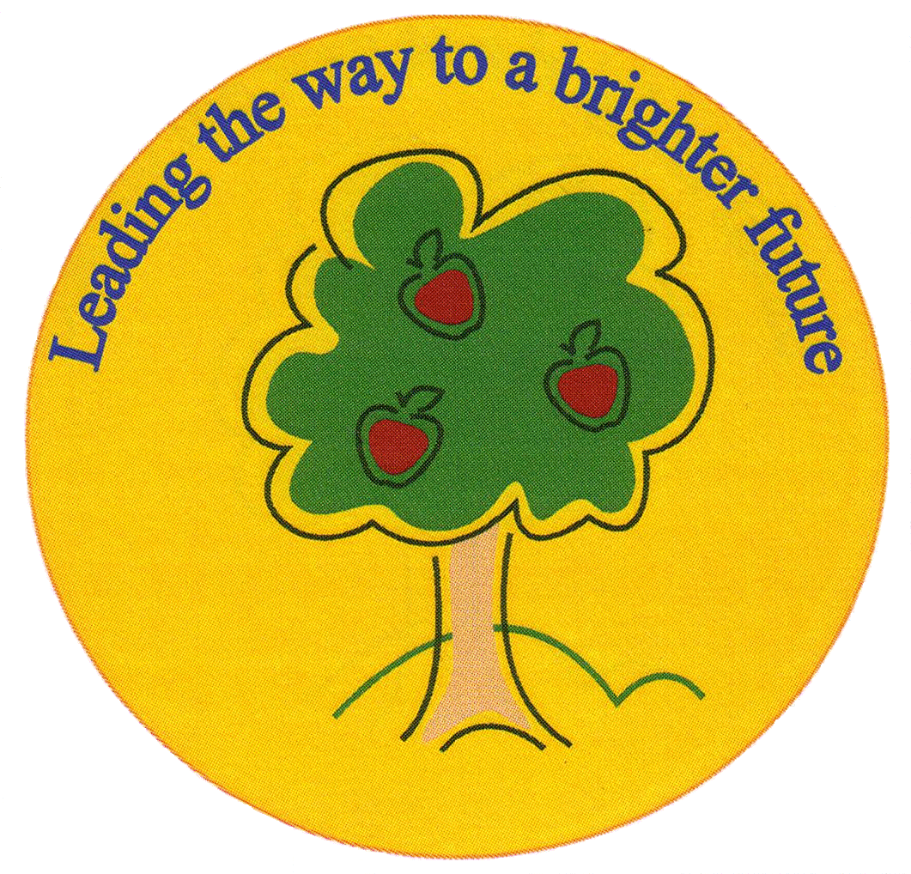
Fulfen Primary School

Rugeley Road
BURNTWOOD
Staffordshire
WS7 9BJ

Telephone: 01543 226070
E-mail: Office@fulfen.staffs.sch.uk

Headteacher: Miss Jane Davies
Voices Together Songbirds Big Sing Workshop
Tuesday 12th March 2019
Dear Parent/carer
We have been invited to take our year 3 children to the Prince of Wales Theatre in Cannock on Tuesday 12th March. The children will be taking part in a fantastic musical workshop.
We will be leaving school at 12.15pm and returning by 3.00pm.There will be no charge for this trip. Children will have an early lunch at school before we leave.
If you would like to come and join in with the workshop then parents are very welcome from 12.45pm.The tickets are £3.00 for adults but free for non-performing children. Tickets are limited to two per family. You can purchase tickets via parent pay and they must be purchased before 1st March 2019.
Please complete the form below giving consent for your child to attend and indicating how many tickets you would require.
Yours sincerely

Mrs Shermer & Year 3 Team
………………………………………………………………………………………………………………………………………………………………
Voices Together Songbirds Big Sing Workshop
Tuesday 12th March 2019

I give permission for my child………………………………………………………………… Class………………

To attend the Big Sing Workshop at the Price of Wales Theatre on Tuesday 12th March 2019
I have paid for adult ticket(s) on Parent pay

I would like to order additional ticket(s) for non-performing children

Signed…………………………………………………………………….. Parent/guardian

