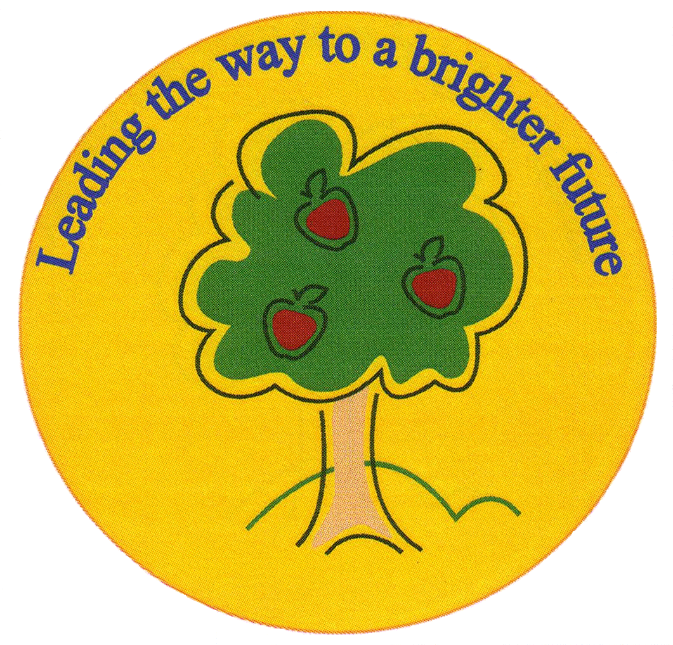
Fulfen Primary School

Rugeley Road
BURNTWOOD
Staffordshire
WS7 9BJ

Telephone: 01543 226070
E-mail: Office @fulfen.staffs.sch.uk
Headteacher: Miss Jane Davies

February 2019
Dear Parents / Carers,

We have some important news to share with you regarding the extended provision here at Fulfen.

Governors have made the decision to bring the Nursery, Pre-School and Before & After School Club (currently delivered by Little Owl Childcare) under the care of Fulfen Primary School from May 2019. This has been a difficult decision as we have worked very closely with Mrs McCormick and Little Owl Childcare for a number of years.

We will continue to offer Nursery provision for 2, 3 and 4 year olds, catering for 15 hour, 30 hours and Think 2 funded places along with those privately funded.

The Before School provision will continue to be available from 7.30am to 8:50am and After School Club from 3.30pm to 6pm.

We will ensure that this process is as seamless as possible for all of our families and we will keep you informed as we move forward. Little Owl Childcare have assured that they will work closely with us to guarantee a smooth transition.

We will be sending out a questionnaire shortly to assess the current on site provision and plan for future development.

We would like to thank Mrs McCormick and Little Owl Childcare for their services to Fulfen Primary School and wish them well for the future.

If you are currently using Little Owl Childcare here at Fulfen or are interested in obtaining more details, please contact Clair Hawkins (School Business Manager) on:
Tel: 01543 226070 email: finance@fulfen.staffs.sch.uk

Yours Sincerely,

Miss J Davies (Head teacher)

