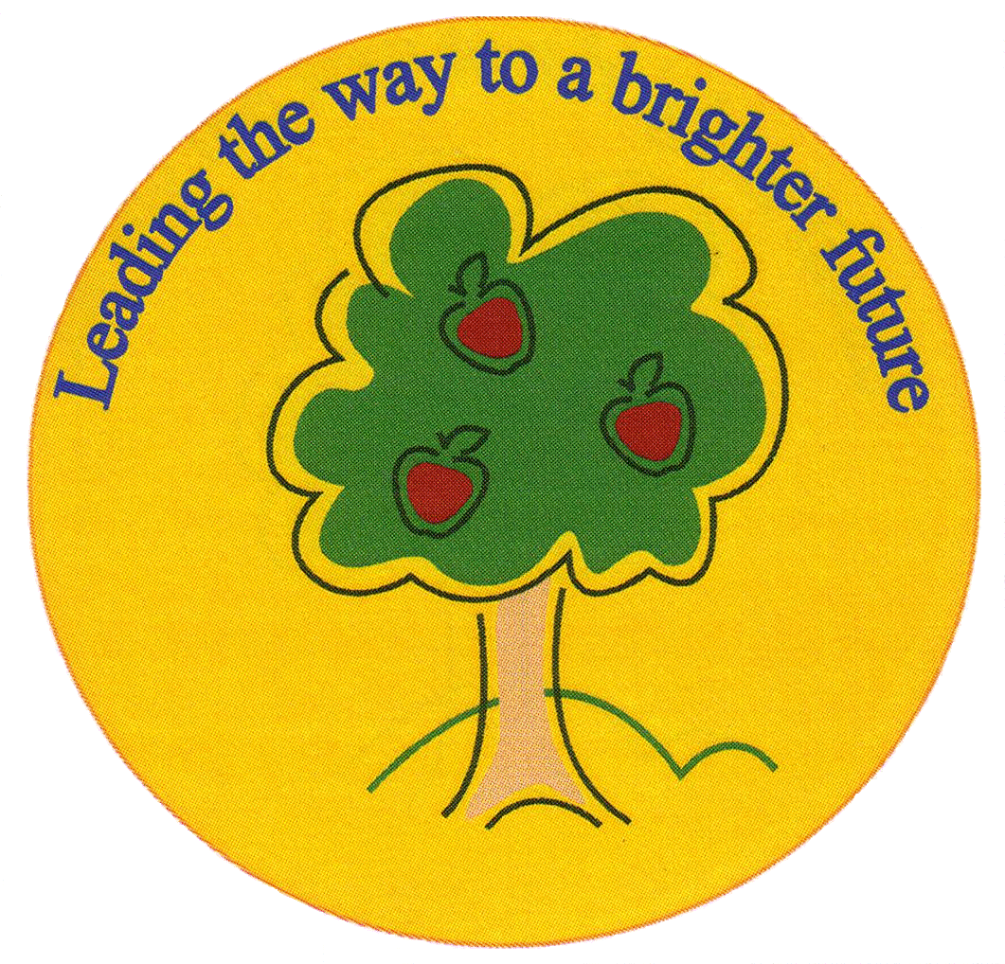
Fulfen Primary School

Rugeley Road
BURNTWOOD
Staffordshire
WS7 9BJ

Telephone: 01543 226070
E-mail: Office @fulfen.staffs.sch.uk

Headteacher: Miss Jane Davies

Dear Parents,
Our current topic is learning about the history of local people. To bring this topic alive and give the children a true hands-on experience, we are going on a school trip to Lichfield on Wednesday 13th March 2019. Whilst there, we will be visiting the Birthplace of Samuel Johnson, where the children will get to dress up and re-enact the story of Samuel Johnson’s life. They will also get the opportunity to see the dictionary that was written by him and discover more about his life. In addition to this visit, we will go to Erasmus Darwin’s house, where the children will be able to investigate and handle several historical artefacts and begin to understand what it was like to live in the 18th century. Also, they will explore the man-made and natural features in the area.
Learning about important people from our locality is a vital part of the history curriculum and this trip will enhance the activities we carry out in school. It is a unique experience, only offered to school visits. We are extremely excited to offer this combination of History, Science and English in two different historic houses.
The children will need to wear their school uniform with sensible shoes for this trip and bring a packed lunch and a drink.
The cost of this trip is only £ 11.00 per child, unfortunately if we do not receive sufficient parental contributions this trip will be cancelled. The contributions will go towards coach travel and entrance to the venues. If your child will require a packed lunch provided by school, can you please make this clear on your reply slip and return it by Monday 25th February.

Thank you,

Mrs Malcolm, Mrs Barber & Miss Bate

Year 2 Trip to Lichfield

Name of child: ____________________________ Class: _____________

I give permission for my child to attend the trip to Lichfield on Wednesday 13th March. I have paid a contribution of £11.00 on Parent Pay.

I will require a packed lunch from school for my child
(in which case, please return slip by 25th February in order for the kitchen to order food)

Signed: __________________________ (person with parental responsibility)

