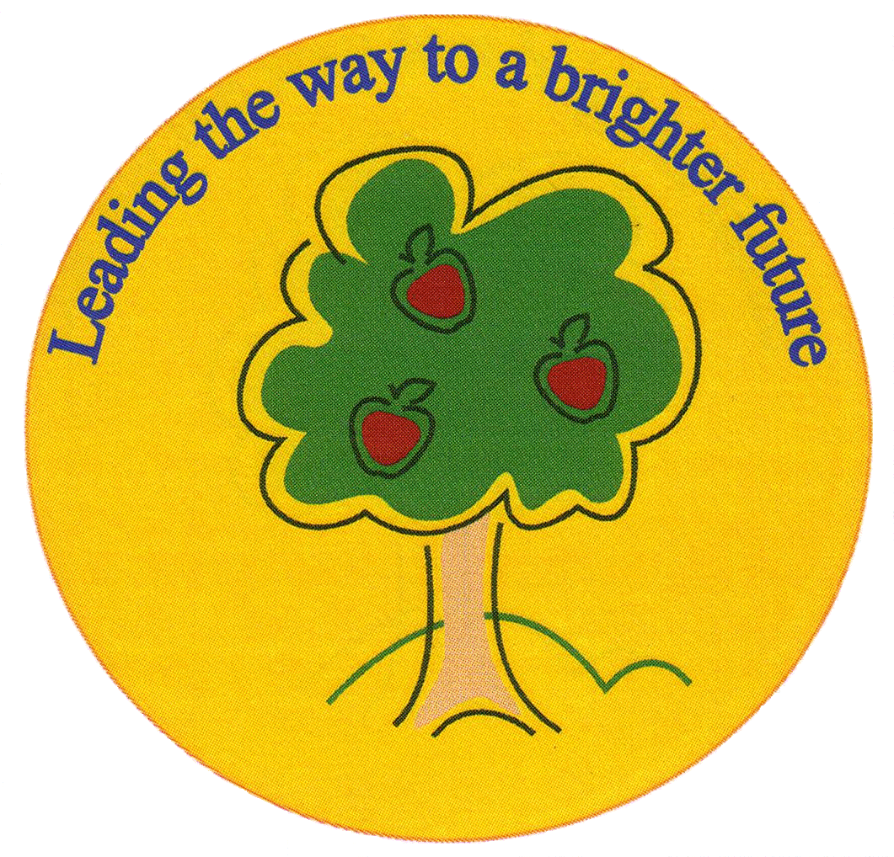
Fulfen Primary School

Rugeley Road
BURNTWOOD
Staffordshire
WS7 9BJ

Telephone: 01543 226070
E-mail: Office@fulfen.staffs.sch.uk

Headteacher: Miss Jane Davies

4th February - 8th February 2019

Dear parent/carers

A group of our year 6 pupils are raising money for Asthma UK.

We will be having an assembly on Wednesday 30th January, where the year 6 children will tell the whole school about Asthma UK and how we can help raise money for them.

The pupils have been very busy making bookmarks and organising a “name the bear” competition and a treasure hunt. During the week commencing 4th February the pupils will be going into each classroom to sell the bookmarks at 50p each and to let the children have a go on the competitions, which are also 50p each.

Children can have as many goes as they wish and the winners will be announced on Friday 8th February in assembly. All the money raised with go to the charity.

We would to say a big thank you to Isla Mason, Harriet Spencer, Amber Drury, Olivia Brookes, Pheobe Higgins, Chelsea Nolan and Rhiannon Gandhi for all their hard work making the bookmarks and donating the prizes.

If you would like any further information on Asthma UK and the work they do, or you would like to make a donation then please visit their website at www.asthma.org.uk.

Thank you for all your support.

Miss Jane Davies
Headteacher

