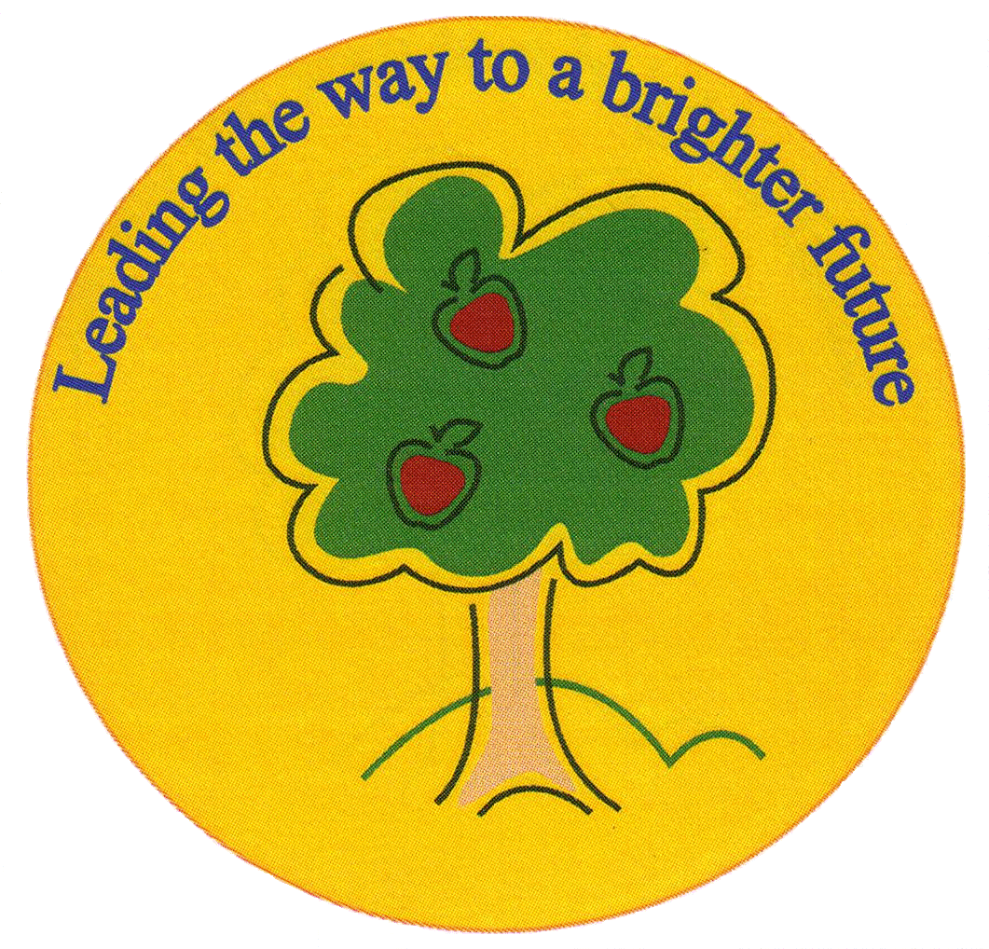
Fulfen Primary School

Rugeley Road
BURNTWOOD
Staffordshire
WS7 9BJ

Telephone: 01543 226070
E-mail: Office @fulfen.staffs.sch.uk

Headteacher: Miss Jane Davies

Dear parents/carers,
We have organised a trip for Year 1 to visit the Black Country Museum on Friday March 1st 2019

As part of our history topic ‘Changes within living memory- toys’ we will be learning all about toys from the past. Our trip to the museum will give the children an insight to what toys were used a long time ago and give them the opportunity to compare them to toys of now, whilst taking part in workshops about old toys.
We will be travelling by coach and will leave at 9:15 and return at 3:15.
Children are required to wear school uniform on the day. A packed lunch will be required. Please pack food and drink items in a plastic bag so that it can all be thrown away at the end of lunch. Please make sure you do not pack any items that contain nuts.

The cost of the trip will be £14.50 this includes admission, two workshops and transport cost for the coach.
If your child requires a packed lunch provided by school, can you please make this clear on your reply slip and return it by Monday February 18th 2019

Yours sincerely

Mrs Owen and Miss Beg
__________________________________________________________________________________
Year 1- Black Country Museum – Friday 1st March 2019

Name of child: ____________________________ Class: _____________

I give permission for my child to attend the trip to the Black Country Museum.

**** I will require a packed lunch from school for my child
(in which case, please return slip by Monday 18th February in order for the kitchen to order food)****

Signed: __________________________ (person with parental responsibility)

Please complete and return the consent form, and pay for the trip via Parent Pay. Unfortunately, if we do not receive enough contributions, this trip will have to be cancelled.

