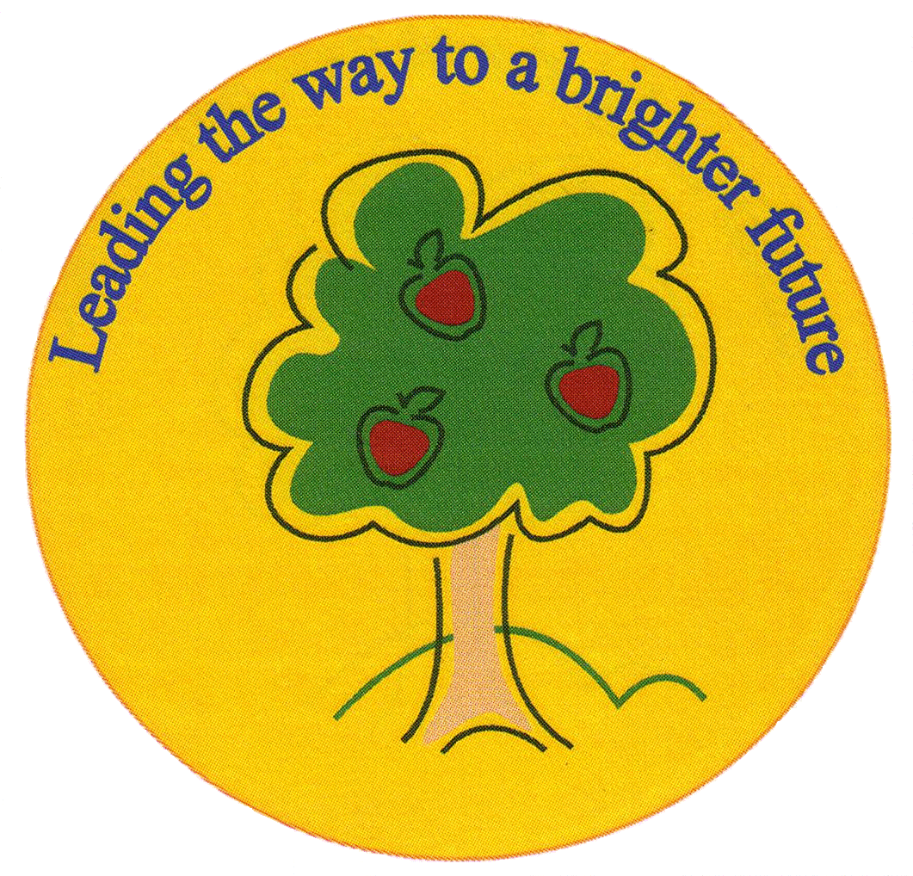
Fulfen Primary School

Rugeley Road
BURNTWOOD
Staffordshire
WS7 9BJ

Telephone: 01543 226070
E-mail: Office@fulfen.staffs.sch.uk

Headteacher: Miss Jane Davies

5th December 2018
Dear parents/carer

EYFS Phonics Workshop Thursday 13th December-Cancelled

Unfortunately, due to unforeseen circumstances it is necessary to rearrange the Phonics Workshop for Reception parents. It will now take place on Thursday 24th January at 3.45-4.30pm.

We are sorry for any inconvenience this may cause. In the meantime please refer to the information provided about Phonics on our class page of the school website.

Many Thanks
Miss Chapman
(Head of Early Years)

