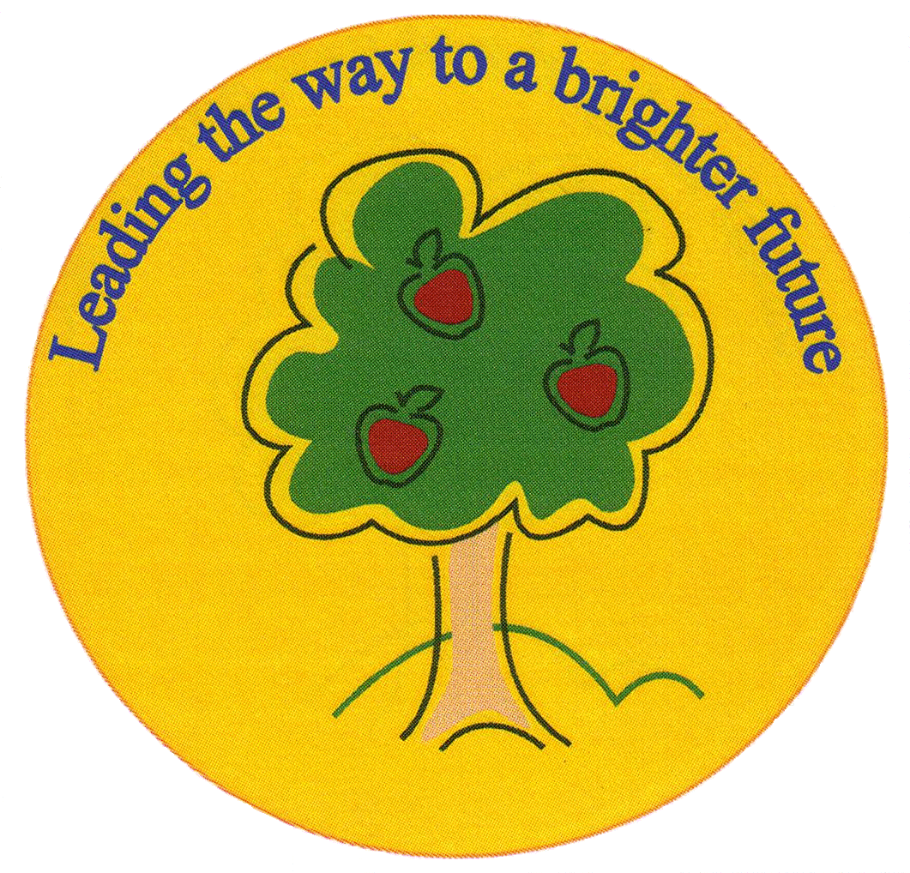
Fulfen Primary School

Rugeley Road
BURNTWOOD
Staffordshire
WS7 9BJ

Telephone: 01543 226070
E-mail: Office@fulfen.staffs.sch.uk

Headteacher: Miss Jane Davies

Dear Parents/Carers
Your child has expressed an interest in joining our new Year5/6 Book Club.
The club is aimed at children who enjoy reading for pleasure, as they will be required to read a few chapters of our chosen book at home every week. This will be followed by a discussion session aimed at giving the children the opportunity to talk about the book and to think a little more deeply about characters, themes, and how the book might relate to other issues.
Children will be required to provide their own copy of the chosen book. The first book – Cogheart by Peter Bunzl - has been chosen from wwwschoolreadinglist.co.uk (Year 6). It is available to buy online from Waterstones, WHSmith, Amazon and other retailers, for prices ranging from £5.49 - £6.99.
The club will meet during Thursday lunchtimes, beginning on Monday 14th January 2019.
Please return the slip below to indicate that you are able to provide a copy of the book for your child to bring to the first session.
Yours sincerely
Mrs Connock and Miss Green

Name of child____________________________________ Class _______

My child would like to join the Year 5/6 Book Club and I am able to provide a copy of Cogheart for my child to bring to the first session of the book club on Monday 14th January 2019.

Signed ________________________________________

