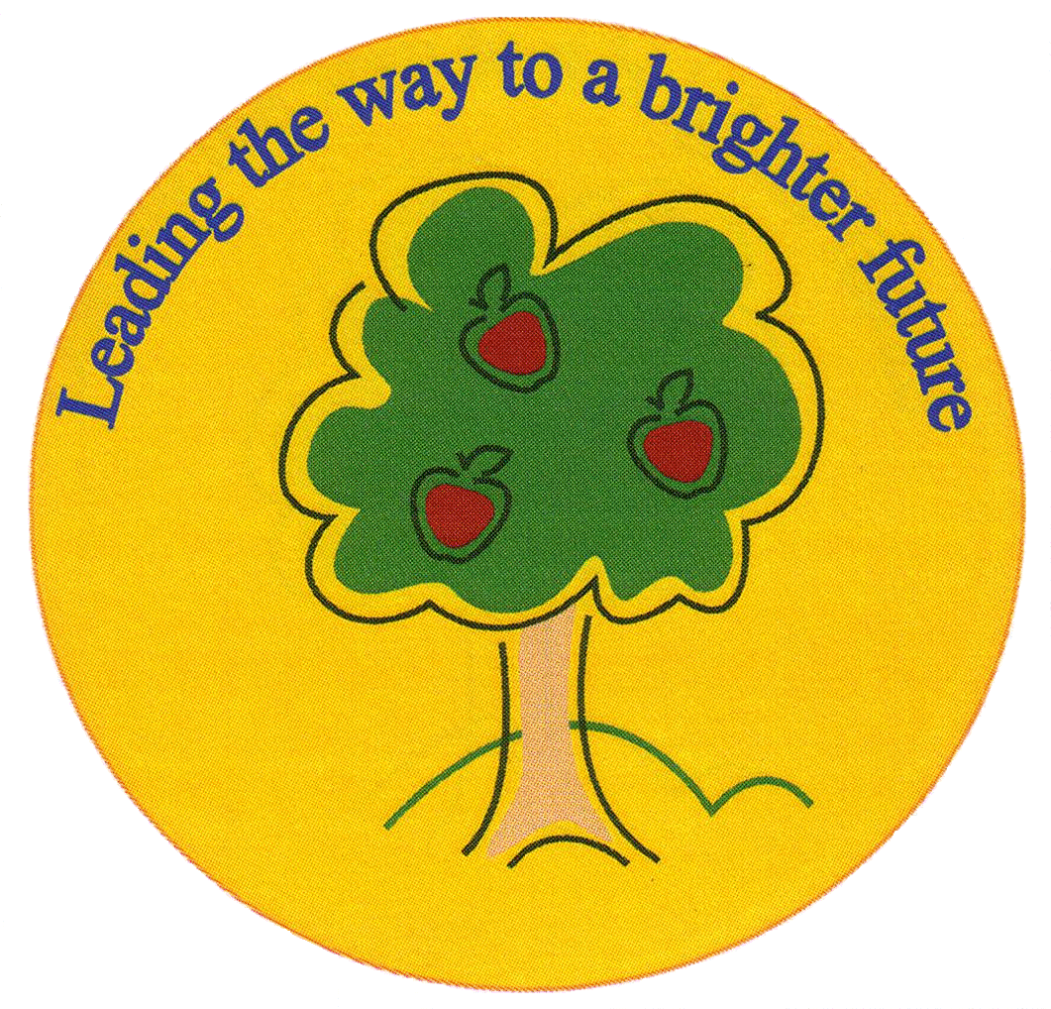
Fulfen Primary School

Rugeley Road
BURNTWOOD
Staffordshire
WS7 9BJ

Telephone: 01543 226070
E-mail: Office@fulfen.staffs.sch.uk

Headteacher: Miss Jane Davies
Christmas Tombola
Friday 14th December


Dear Parents & Carers

On Friday 14th December, we will be holding a Christmas Chocolate & Bottle Tombola. The Tombola will be open at 8.15am and again at 3.30pm, the children will have another chance to purchase tickets during break time for the chocolate tombola only.
On Friday 30th November, we will be having a non-uniform day but instead of bringing in £1 we are asking the children to donate a bottle or chocolate towards the tombola. The bottle can be anything from tomato ketchup to Champagne and the chocolate can be anything at all.
We always appreciate the support you give us so please come and join in the fun; all the money raised will be going to towards our school funds.

The Tombola will be priced at £1 for five chances to win and the children can have as many goes as they wish.

If you have any questions or are able to help in any way please contact the office on 01543 226070.

Yours sincerely

Miss J Davies
Headteacher

