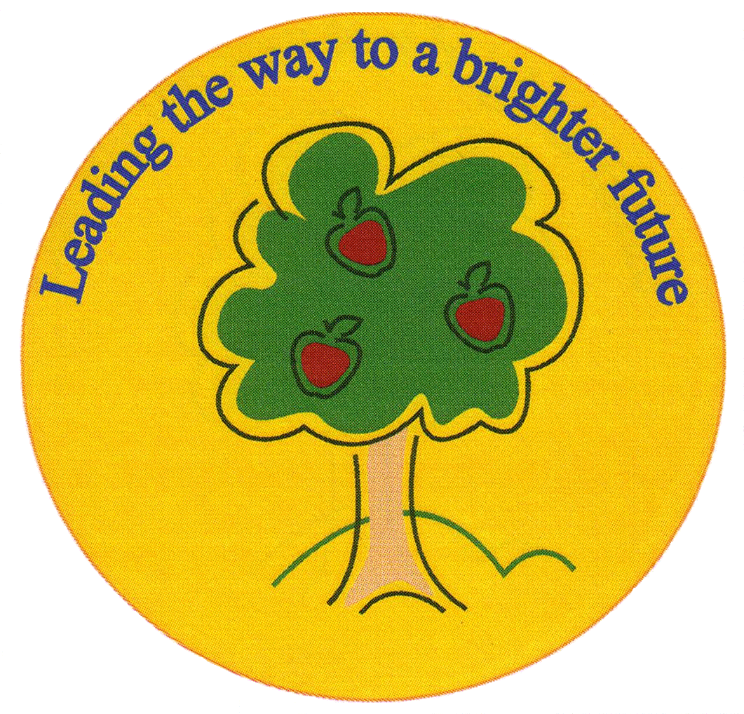
Fulfen Primary School

Rugeley Road
BURNTWOOD
Staffordshire
WS7 9BJ

Telephone: 01543 226070
E-mail: Office @fulfen.staffs.sch.uk

Headteacher: Miss Jane Davies
1st October 2018

Dear Parents/Carers,

As part of our Great Fire of London topic, we have arranged a trip to Selly Manor Museum, Bournville. The children will experience what life would have been like in 1666. During the trip, they will experience such things as handling artefacts and see what a dangerous time it was to live if your house was made of wood! It will take place on Thursday 15th November.

The cost of the trip is £10.50 per child. This includes the coach costs, entry to the museum and a museum expert sharing their knowledge.

The children need to bring/wear:
- a waterproof coat,
- sensible footwear for uneven surfaces (closed toe outdoor shoes),
- normal school uniform,
- a packed lunch,
- a drink in a plastic flask/bottle (non fizzy please).
If you would like school to provide the packed lunch, then could you please order it using the slip below.

We hope you will support us in this exciting new trip and would be grateful if you could return the slip and pay through our Parent Pay System by Friday 26th October. Unfortunately, if there are not enough contributions to cover the cost of the trip, it will have to be cancelled.

Many thanks,
Year 2 team.
……………………………………………………………………………………………………………………………………………………………………
Year 2 Trip to Selly Manor Museum – 15th November 2018

I/we, the parents/carers of………………………………………………………………………………….. give permission for them to take part in the trip and have paid a contribution of £10.50 to the trip on Parent Pay.

We would like to order a packed lunch. (please tick if required)

