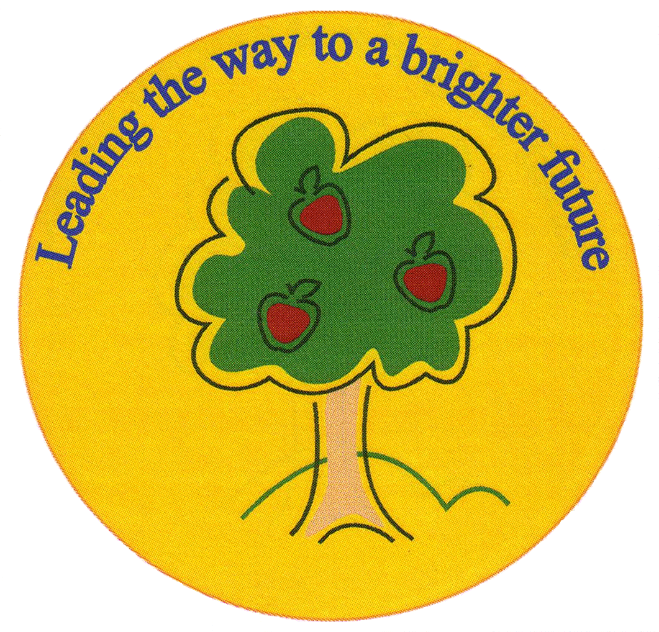
Fulfen Primary School

Rugeley Road
BURNTWOOD
Staffordshire
WS7 9BJ
Telephone: 01543 226070

E-mail: Office@fulfen.staffs.sch.uk

Headteacher: Miss Jane Davies
Harvest Festival
Tuesday 9th October

Dear Parents/Carers

For Harvest Festival this year, we are supporting Age UK and in particular people in the Cannock area who have Dementia.

Over 850,000 people in the UK are living with dementia - this is one in six people over the age of 80. Age UK offer community-based support services for people living with dementia and their carers to improve their quality of life.

Fulfen Primary School have agreed to support this charity and we are asking for non-perishable food items, especially food in tins & packets. Children can bring in one item or several items. All the food will be on display in our reception area before it is collected on Wednesday October 10th.

We do hope you can join us for the harvest festival performances on 9th October:-

KEY STAGE 2 9.10am – 10.00am

KEY STAGE 1, EARLY YEAR’S & TREETOPS 10.20am – 11.10am

You are welcome to Join us for a cup of tea and a biscuit

9.00am for the first performance &

11.10am for the second performance.

If you would like more information about age Uk and the work they do please look at their website www.ageuk.org.uk

Yours sincerely
Jane Davies
Headteacher

