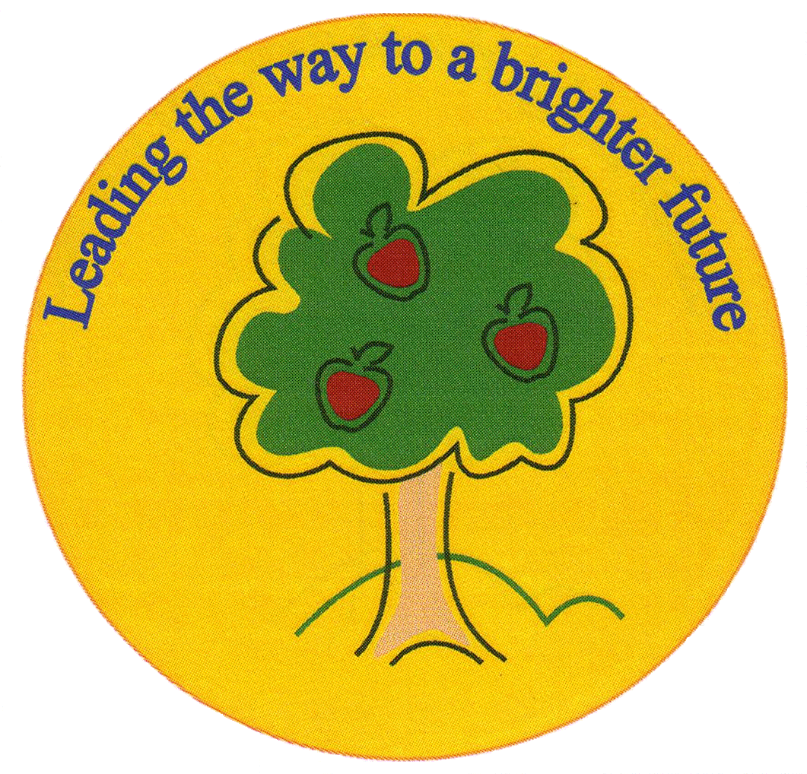
Fulfen Primary School

Rugeley Road
BURNTWOOD
Staffordshire
WS7 9BJ

Telephone: 01543 226070
E-mail: Office @fulfen.staffs.sch.uk

Headteacher: Miss Jane Davies
Dear Parents/Carers,
As part of Year 1’s topic ‘Paws, Claws and Whiskers’, we are excited to announce that Animal Visits Midlands will be coming into school on Friday 26th October 2018.

The afternoon session will allow the children to explore and learn about a variety of animals and their habitats. They will have the opportunity to interact with snakes, lizards and lots of mini beasts! We ask for a voluntary contribution of £3 to cover the costs of the company’s visit. This can be paid via ParentPay. Unfortunately, if we are unable to cover costs, the visit may not be able to go ahead.

We believe that this experience will be fun and informative for the children, ending our topic in style! Please complete the permission slip by Friday 19th October and return it to the office.

If you have any questions regarding the animal visit, please do not hesitate to contact a member of the Year 1 team.

Thank you for your continued support.

Miss Beg and Mrs Owen.
…………………………………………………………………………………………………………………
Year 1 animal visit into school on Friday 26th October 2018.

Child’s name…………………………………………………………………Class…………………………..

I give/do not give permission for my child to attend the in-school animal workshop.

Signed……………………………………………………………….. Date……………………………………

