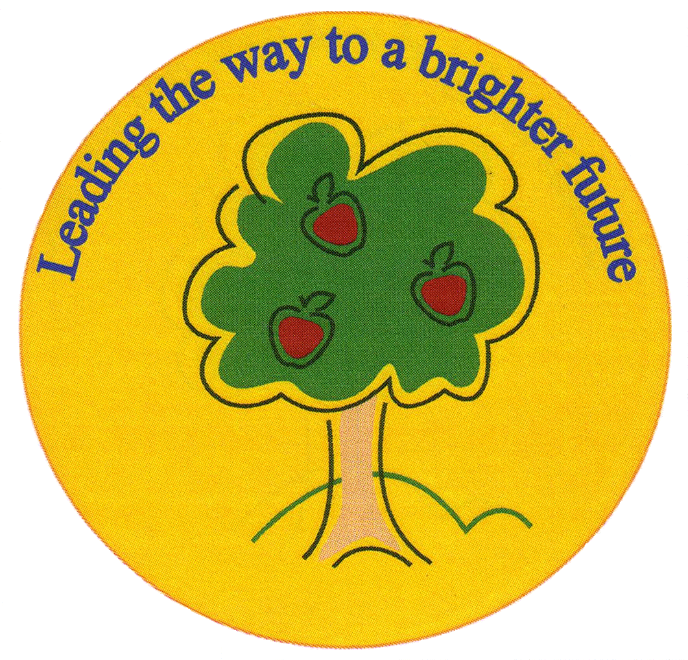
Fulfen Primary School

Rugeley Road
BURNTWOOD
Staffordshire
WS7 9BJ

Telephone: 01543 226070
E-mail: office@fulfen.staffs.sch.uk

Headteacher: Miss Jane Davies


Time to Get Baking

Fulfen Primary school is proud to announce that we will be supporting the MacMillan “World’s Biggest Coffee Morning” again this year on:-

Friday 28th September 2018

We are asking for donations of shop cakes and cookies to be brought into school during the week commencing 24th September. Any homemade cakes can be brought into school from Thursday morning.

We would like to invite you, your relatives, neighbours and friends to join us for a cup of coffee/tea and a cake from 8.30am – 9.15am on Friday 28th September. The cakes will also be on sale to children at break time and after school.

Our Year 6 children are helping to organise this event, please come along and support them, last year we raised a staggering £ 770.00! Every penny will be donated to this worthwhile cause.

“Cakes Taste Better Together”.

Yours sincerely

Miss Jane Davies
Headteacher

