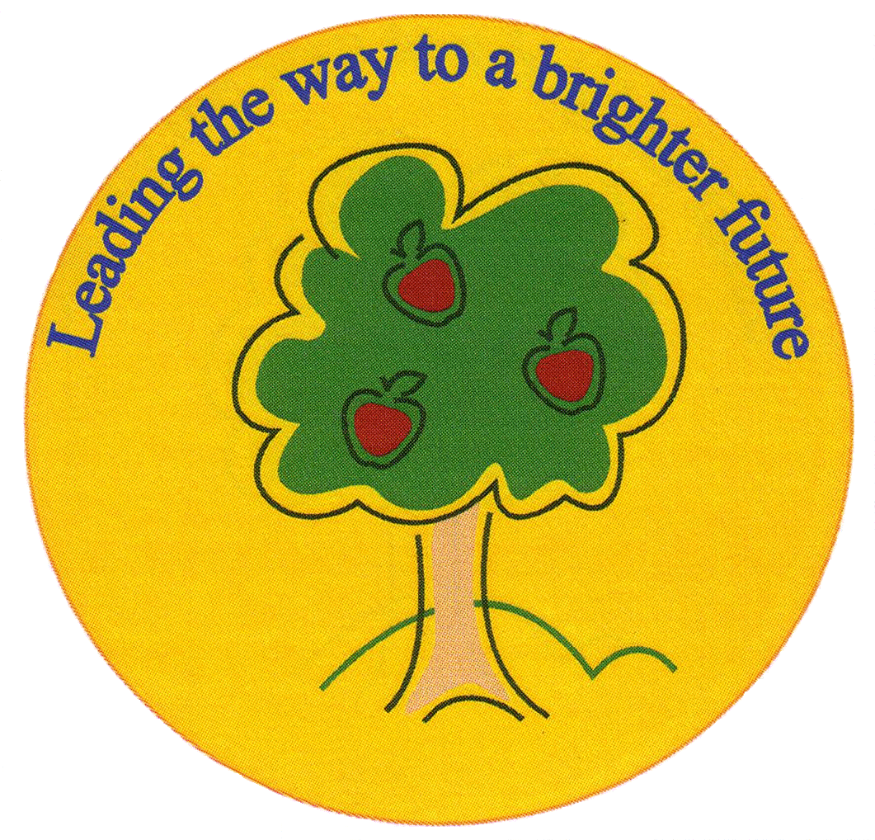
Fulfen Primary School

Rugeley Road
BURNTWOOD
Staffordshire
WS7 9BJ

Telephone: 01543 226070
E-mail: Office @fulfen.staffs.sch.uk

Headteacher: Miss Jane Davies
4th September 2018
Dear Parents/Carers

Consents
Please find attached a student consent form, which we would be grateful if you would complete.

There are times that we may need to take children out of school for local trips, we may also take photographs to be used for various purposes. It is therefore important that the attached form is completed by the deadline below, to allow your child to take part in up and coming lessons. The attached consent form gives further explanations. Please circle “Yes or No” against each heading and sign/date the bottom of the form. Please return the form by Friday 14th September 2018.

If the form is not returned by this date, we will presume that you consent to all areas.

Snack
For Year Groups Reception to Year 6, snack is available each day from the school kitchen for your child to buy at morning playtime. The following items are available:

Toast 25p Fruit 40p
Teacake 30p Yoghurt 45p
Crumpet 30p Milk 25p
Bacon Roll (Tuesday only) 75p Milkshake 60p

Please note we do not have the facility to give change so your child must bring in the exact change for the items they want each day.

Please note that free fruit is still provided and that children are welcome to bring their own snack into school if you don’t want to pay for school snack.

Meet the Teacher Evenings
During the next two weeks, we are holding some Meet the Teacher evenings. These evenings are a chance for you to come into school, find out key information and dates for the year group and to discuss how you can support your child’s learning at home. You will also have a chance to have a look around the classrooms and ask any questions.

The meetings will start at 6.00pm with a short presentation by the year teachers and last for about an hour.

Important - The meetings are for parent/carers only as we do not have the facilities to supervise children on these evenings.

The dates for each year group are listed below. If you have any queries please do not hesitate to contact us.

Date | Year Group | Time
Tuesday September 11th | Year 6 | 6.00pm
Wednesday September 12th | Year 5 | 6.00pm
Thursday September 13th | Year 4 | 6.00pm
Tuesday September 18th | Year 2 | 6.00pm
Wednesday September 19th | Year 1 | 6.00 pm
Thursday September 20th | Year 3 | 6.00pm
Wednesday September 26th | EYFS | 6.00pm

