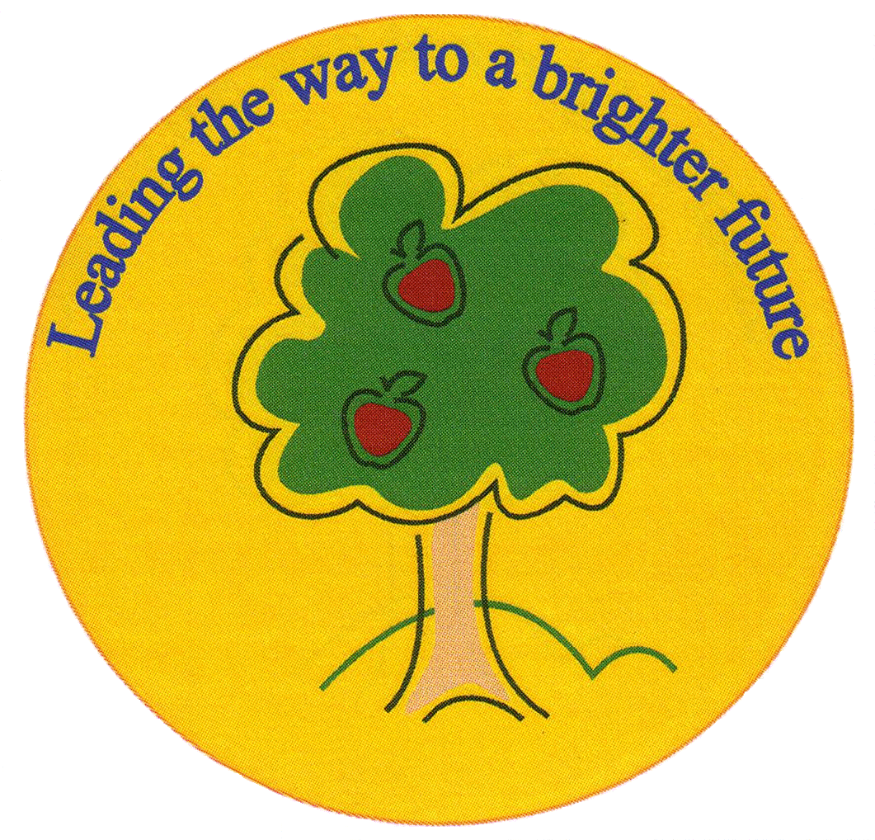
Fulfen Primary School

Rugeley Road
BURNTWOOD
Staffordshire
WS7 9BJ

Telephone: 01543 226070
E-mail: Office @fulfen.staffs.sch.uk

Headteacher: Miss Jane Davies

5th September 2018

Dear Parents/Carers

As part of our Literacy curriculum this term, we would like our children to participate in an Astronaut Training Day on the 10th September. Children will find out what it's really like to train to become an astronaut by completing activities designed by NASA to develop their speed, reaction times, dexterity, strength, agility and co-ordination, as well as improving their communication and problem solving skills. These are all skills that are essential for astronauts.

We will also be making some astronaut treats just like the real astronauts eat and drink when in space! In order to purchase ingredients, we are asking for a £1 voluntary contribution, to be handed in by 7th September.

If your child has a food allergy and you are not sure if school has been made aware, would you please inform us at the school office.

Please could all children arrive in sports clothes on this day in order to participate fully in the activities - trainers, joggers or shorts and t-shirt etc. Please could you also ensure your child brings a water bottle with them.

We will still be going swimming in the afternoon so children will also need their swimming kits.

Thank you for your co-operation,

The Year 5 team.

