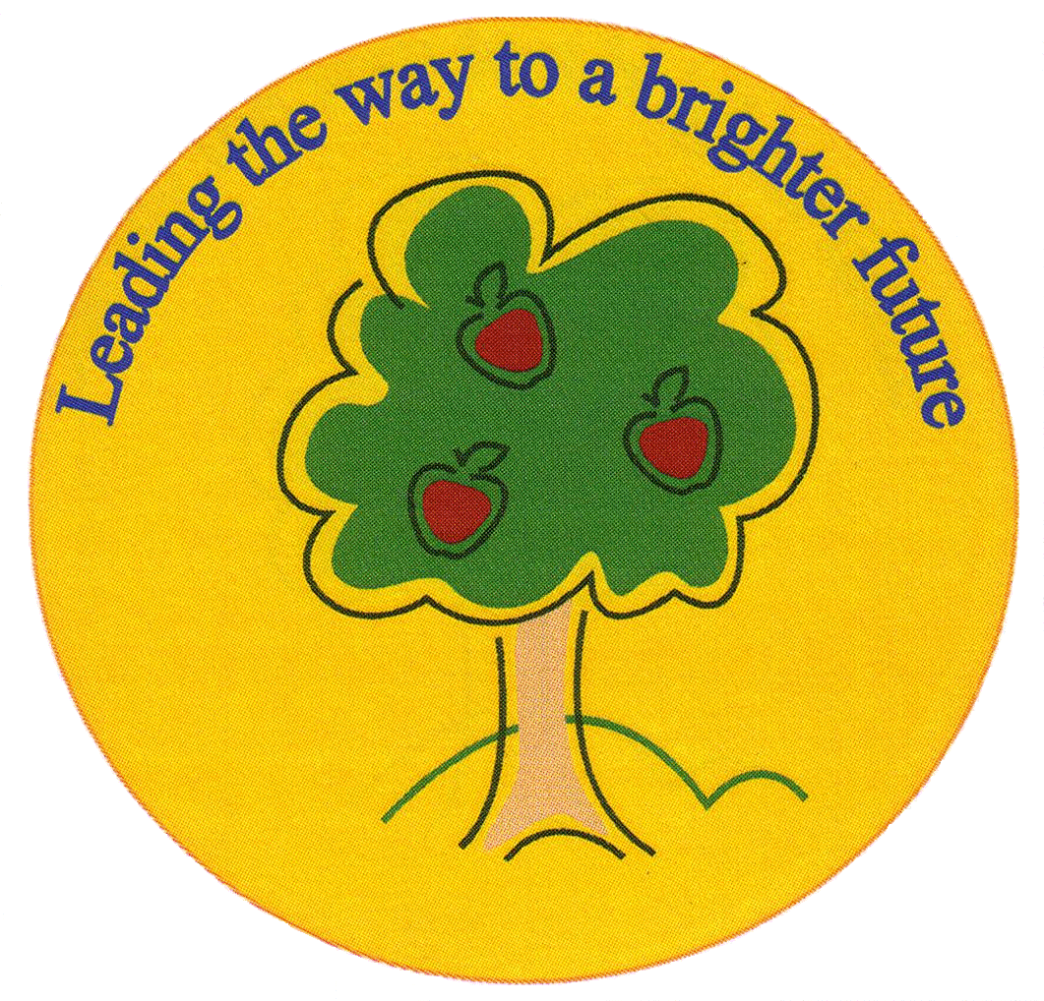
Fulfen Primary School

Rugeley Road
BURNTWOOD
Staffordshire
WS7 9BJ

Telephone: 01543 226070
E-mail: Office @fulfen.staffs.sch.uk

Headteacher: Miss Jane Davies

4th July 2018

Dear Parents/Carers

Year 6 Residential Trip(s)

As you are aware, there will be a Parent Information Meeting on Thursday 19th July at 6.00pm, to talk about the 2019 residential trip for Year 6 to Madrid.

We are also looking into the possibility of offering a UK residential trip to Laches Wood, which is an outwards bounds centre in Coven near Wolverhampton. Further information will follow in September regarding both options. At this point, we will be asking parents to give us their preference, which will inform us of the feasibility of the trips.

A decision will then be made, based on numbers, and we hope that parents support the final decision. In the event that we have enough interest for both trips, we will endeavour to run both where possible. Please note if we are able to run both trips, pupils will only have the option to attend only one.

Residential trips have always played a very important part in enhancing our pupil’s experiences at Fulfen Primary School. It will be a unique opportunity for them to create wonderful memories that they will carry forward into their next chapter at Secondary School.

If you cannot attend the Madrid meeting but would like some more information please can you ring the office on 01543 226070 after the 19th.

We look forward to planning our exciting trip(s) with you early in the Autumn term.

Yours sincerely
Miss J Davies
Headteacher

