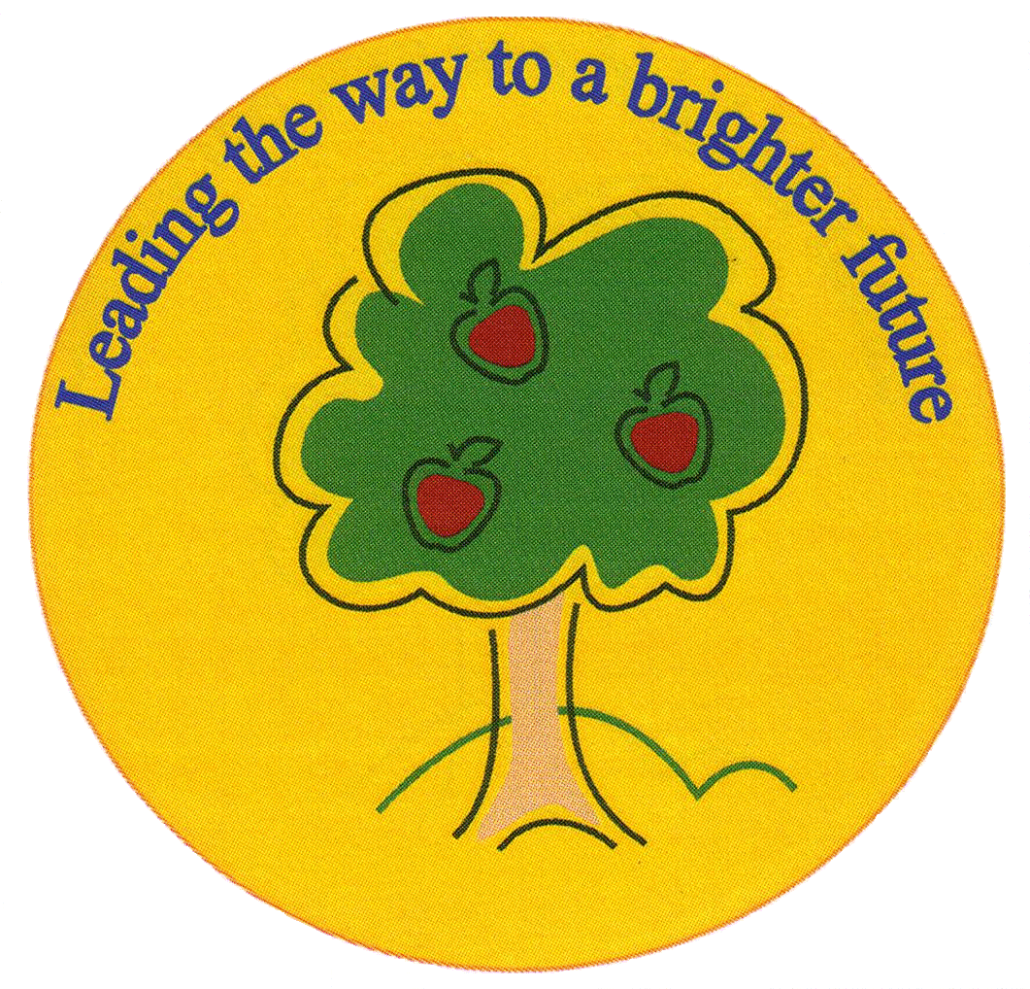
Fulfen Primary School

Rugeley Road
BURNTWOOD
Staffordshire
WS7 9BJ

Telephone: 01543 226070
E-mail: Office @fulfen.staffs.sch.uk

Headteacher: Miss Jane Davies

Dear parents/carers,

Year 3 will be visiting Conkers Discovery Centre, near Ashby –de-la- Zouch, on Friday 6th July as part of our science unit of plants. This will be a great opportunity to consolidate and extend our classroom learning in a fabulous setting.

The children will be participating in “The Secret Life of Seeds” which is a ranger led activity. During this interactive woodland walk the children are taught about the dispersal and life of seeds. They are encouraged to find and identify different seeds and discuss how they might be dispersed. Seeds collected during the woodland walk are then used to decorate a kite representing wind dispersal back in the Conkers Education Room.

They will also visit the exciting 4D cinema where the children will be immersed into a world of special effects including lightning and smells!

Year 3 will also have time to explore both the indoor exhibits and outdoor trails and time to visit the Conkers shop.

The children will be leaving school at 9.00 a.m. and returning to school by 3.30 p.m. Further details about the trip will follow nearer the date.

We would be grateful if a donation of £10 could be made to cover the cost of this trip. This includes the coach hire from Fulfen Primary School to Conkers, entry to the exhibits and the ranger led activity. Payments can be made on the ParentPay system. Please note, if sufficient funds are not achieved the trip may have to be cancelled.
Please could you fill in the form below and return it to your child’s class teacher.

I give permission for my child ____________________________________________________
to participate in the year 3 trip to Conkers.
I enclose a donation of £10 □
I will pay on the Parent Pay system □
Parent/Carer Signature _______________________________________________________

