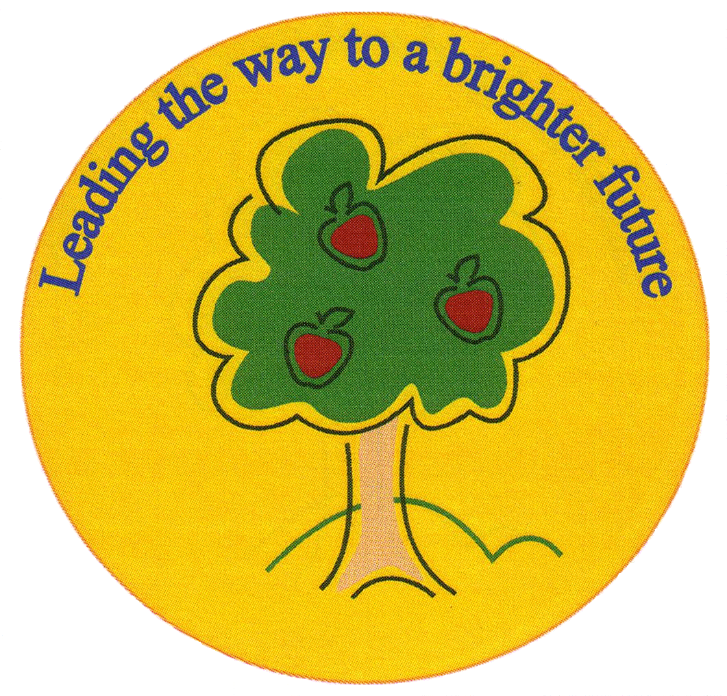
Fulfen Primary School

Rugeley Road
BURNTWOOD
Staffordshire
WS7 9BJ

Telephone: 01543 226070
E-mail: Office @fulfen.staffs.sch.uk

Headteacher: Miss Jane Davies

The Roving Bookshop 

Are coming to Fulfen School on:-
Thursday 21st June 2018
Early Years
There will be over 3000 books to choose from You can purchase books before school from 8.30am and after school from 3.30pm. The company accept cash cheques and credit cards.

Early Years parents are welcome to accompany their children into the hall at 8.30am or after school at 3.30pm. If your child goes to Little Owls, their teachers will take them during the day who will help and advise them on their choice of book. Please can you let Little Owls staff know if you wish your child to have a look at the books. If you want them to purchase a book, please could you put their money in a named envelope?

The Roving Bookshop will only be at Fulfen for one day, so please do not miss out on this great opportunity to buy a book for your child, and to help raise vital funds for our school library. If you have any questions please do not hesitate to contact the office on 01543 226070.

Thank you for your continued support.

