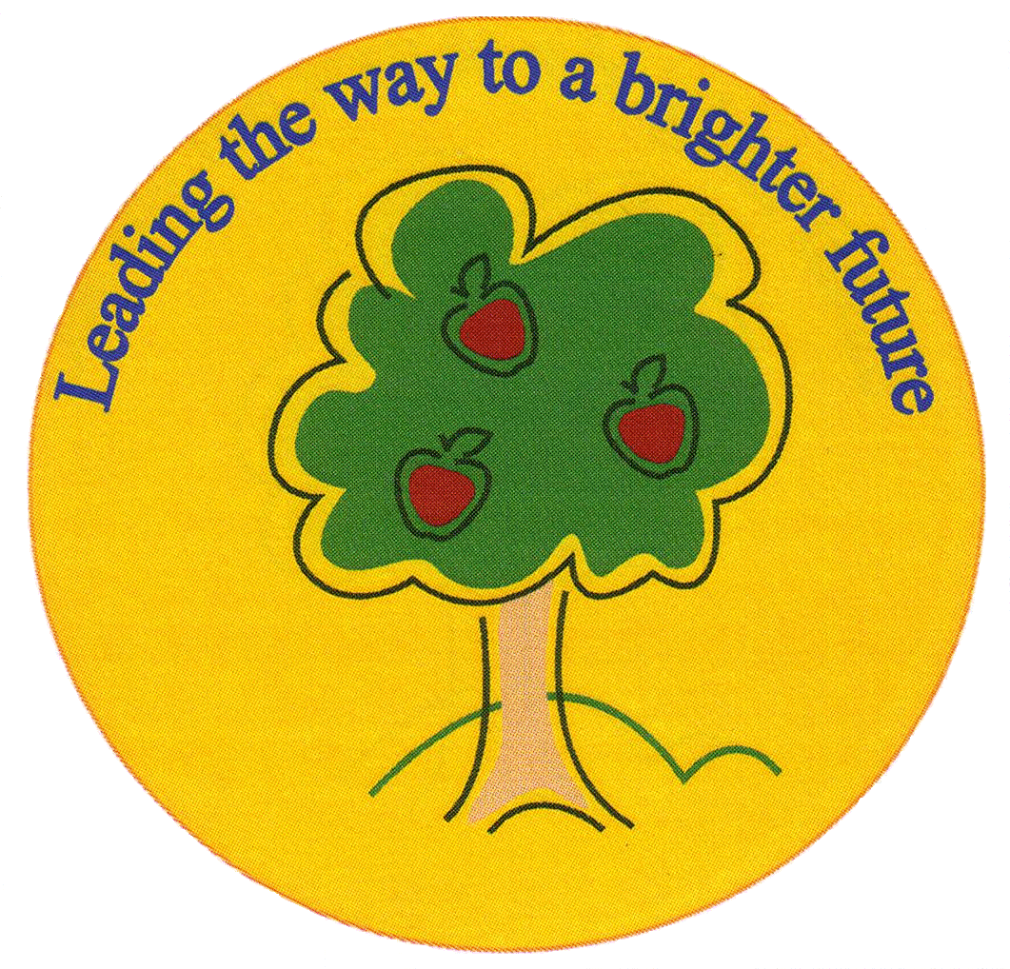
Fulfen Primary School

Rugeley Road
BURNTWOOD
Staffordshire
WS7 9BJ

Telephone: 01543 226070
E-mail: Office @fulfen.staffs.sch.uk

Headteacher: Miss Jane Davies

Dear parents and carers,
The NSPCC’s ‘Speak out. Stay safe.’ programme is visiting our school to make sure our pupils have the knowledge and understanding they need to stay safe from abuse.
I’m pleased to tell you that we will be working with the NSPCC, the UK’s leading children’s charity, who’ll be delivering their ‘Speak out. Stay safe.’ programme on Monday 9th July 2018. This is a nationwide programme for every primary-school-aged child in the UK and Channel Islands. With the help of their friendly mascot Buddy, the NSPCC will be presenting assemblies and workshops to the children in our school.
"NSPCC has helped me to build the confidence to tell people about my worries and problems." Child’s feedback

What is the ‘Speak out. Stay safe.’ programme?
Through child-friendly, interactive assemblies and workshops their specially trained staff and volunteers will give our children information about how to keep themselves safe from harm and how to get help if they have any worries, sensitively discussing issues like bullying and sexual abuse, without using scary words or adult language.
We have studied the content of the materials and heard from other schools, who have participated, and we are extremely confident that they are appropriate for primary-school-aged children. By the end of their visit, we are convinced children will feel empowered – knowing how they can speak out and stay safe.
"This service provides important information in a child-friendly way – it should be made mandatory in all schools. A brilliant service!" Teacher, Wistaston Primary, Crewe
If you would like any more information about the NSPCC ‘Speak out. Stay safe.’ programme, including frequently asked questions, you can find it on the NSPCC website nspcc.org.uk/schools or please contact the school.

Talking about the Underwear Rule with your children
The NSPCC’s work in schools will help encourage conversations about staying safe – and they have a number of child-friendly materials to help you carry on the conversation afterwards. That includes ‘The Underwear Rule’, a simple way for parents to help keep children safe from sexual abuse – without using scary words or even mentioning sex.

The guide uses the rules of PANTS to teach children that their body belongs to them and them alone. You can find out more and download the free resources at nspcc.org.uk/pants
If you’d like to know more about the NSPCC’s work, or take a look at the wide range of information and advice which is available for parents and carers, please visit their website nspcc.org.uk/preventing-abuse/keeping-children-safe/
How will the sessions be delivered to the children?
There will be an assembly for all KS1 children and a separate assembly for all KS2 children. There will also be classroom sessions for children in Years 5 and 6. The sessions will be delivered to individual classes and their class teacher will be present.

Please complete the consent form below to indicate whether you give permission for your child to take part in the assembly session and workshop (workshop is for Year 5 and Year 6 only). Please return the consent form to your child’s class teacher.
Yours sincerely,

Miss J Davies
Headteacher.

___________________________________________________________________________________

Name of child: ___________________________________ Class: ________________

Please tick

I give permission for my children to take part in the NSPCC ‘Speak out. Stay Safe.’
programme of activities on Monday 9th July 2018

I do not give permission for my children to take part in the NSPCC ‘Speak out. Stay Safe.’
programme of activities on Monday 9th July 2018

Signed: __________________________________ Date: ________________________

Print name: ____________________________________

