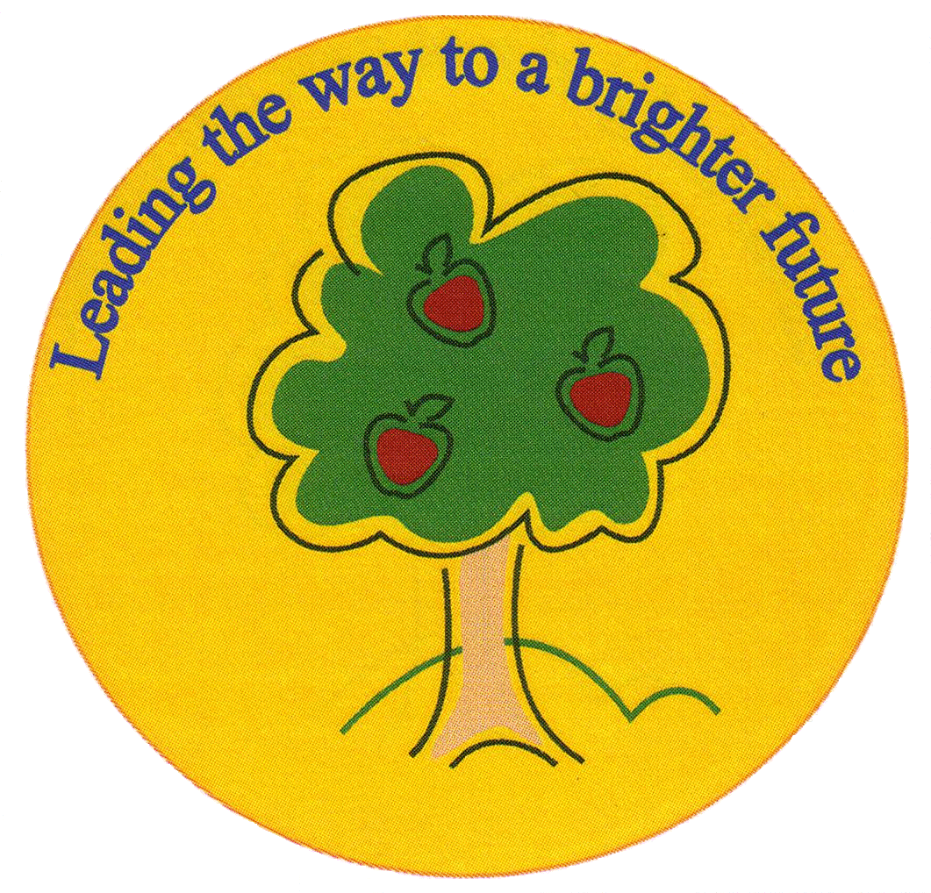
Fulfen Primary School

Rugeley Road
BURNTWOOD
Staffordshire
WS7 9BJ

Telephone: 01543 226070
E-mail: Office @fulfen.staffs.sch.uk

Headteacher: Miss Jane Davies

Bikeability Year 5

Dear Parents/Carers

Thank you very much for returning your preferences for the Bikeability course.

If you chose Option 1, which was to participate in Bikeability in the Autumn Term when your child will be in year 6, we will let you know the dates that have been booked for you after half term.

If you chose Option 2, which was to participate in Bikeability before the end of the summer term, the course will take place on Wednesday 11th July and will be for 1 day. We will send you more information shortly.The payment of £30.00 will be on ParentPay from Monday 4th June.

If you have any questions regarding these arrangements please do not hesitate to contact the office on 01543 226070.

Yours sincerely

Jane Davies
Headteacher

