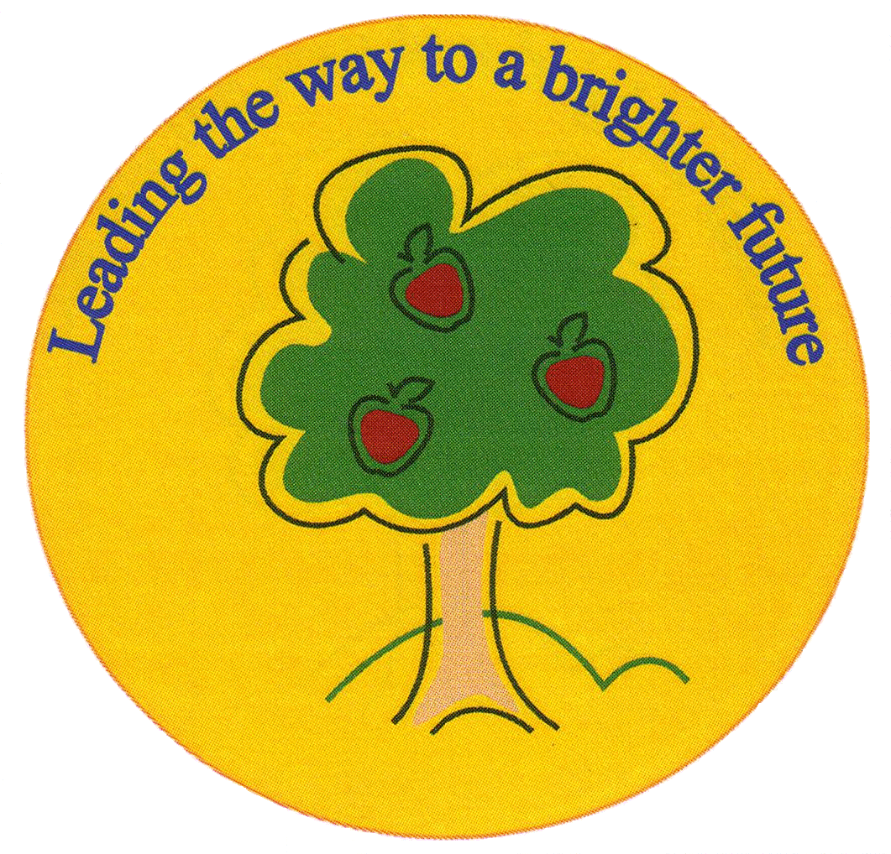
Fulfen Primary School

Rugeley Road
BURNTWOOD
Staffordshire
WS7 9BJ

Telephone: 01543 510400
Facsimile: 01543 510405
E-mail: office@fulfen .staffs.sch.uk

Dear Parents/Carers

On Wednesday 13th June 2018, we will be taking the children in Year 5 to Conkers in Derbyshire to complement their Geography topic. During the day, the children will be using their map reading skills to complete an orienteering challenge, experience the 4D cinema, explore nature walks and enjoy hands on galleries.

We are asking for a voluntary contribution of £11.00 to cover the cost of the coach, entrance fee and workshop. However, if we do not receive enough voluntary contributions, unfortunately the trip may need to be cancelled.

Payment should be made using the Parentpay system before Friday 25th May 2018.

We will be departing from Fulfen Primary School at 9.10am and returning at approximately 3.20pm. Please could you provide your child with a packed lunch and a drink. No glass bottles please. Children are to wear school uniform as normal.

Yours sincerely

Mrs Shermer Miss Morgan Mrs Connock

Year 5 Visit to Conkers
Childs Name__________________________________

Class___________________

I give permission for my child to visit Conkers on Wednesday 13th June 2018

I have paid an £11.00 contribution using Parentpay.

Signed___________________________ Date________________________

