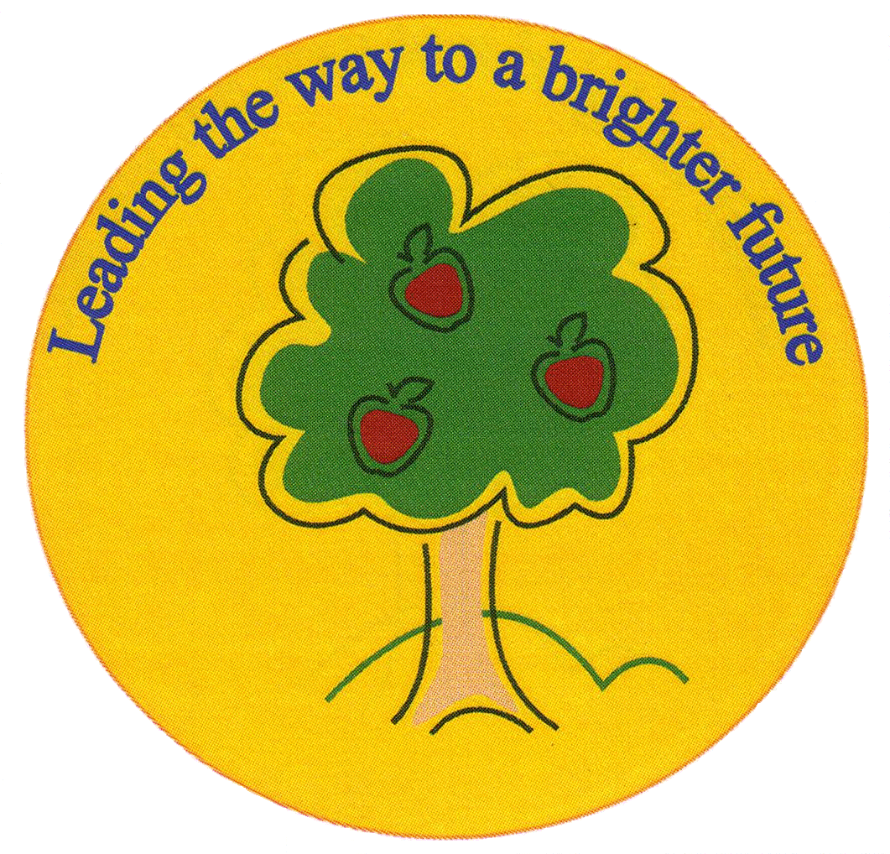
Fulfen Primary School

Rugeley Road
BURNTWOOD
Staffordshire
WS7 9BJ

Telephone: 01543 226070
E-mail: Office @fulfen.staffs.sch.uk

Headteacher: Miss Jane Davies

FULFEN PRIMARY SCHOOL
1978 - 2018
Dear Parent/carers

It is with great pleasure that I invite you to Fulfen Primary School’s 40th Birthday Celebrations. We will be having a Birthday Party on Friday 22nd June 2018. All the pupils and teachers will be involved and I hope Parents, Carers, Grandparents and Neighbours will come along and help us celebrate this very special occasion. Below is a brief itinerary for what will be a very busy day.
We will be celebrating in true “Fulfen Style” by dressing up and having a 1970s themed day.
KS1
The children will be welcomed into school by the Erasmus Darwin Jazz Band, Stilt Walkers and Jugglers.
At 9.00am, adults please make your way to our events marquee on the field where you will be truly amazed by the pupils from KS1 who will be performing songs and dances from the 70’s. Following this, you will be invited to look at the children’s 70’s displays in their classrooms.

The children will have lunch as normal and we ask that you collect them from school at the normal time of 3.30pm.

At 3.30pm, the Lichfield Town Crier, Mr Ken Knowles, will facilitate the unveiling of our Fulfen Sculpture and the cutting of the Birthday Cake just outside the main reception area.

At 4.00pm, The Birthday Finale of “Stars in your Eyes” will take place in the events marquee. Everyone is welcome to come and watch our fantastic pupils transform into famous pop stars from the last 40 years. The children are very excited because there will be some very special performances from teachers and support staff, including “Spice Girls”, “S Club 7” and “Cher”.

Some refreshments will be available throughout the morning free of charge. However, there will sweets available to purchase. Please bring along some change.

On Monday 25th June, the children will all receive a commemorative teddy bear, and a piece of birthday cake. This will be made from an original recipe that the children used 40 years ago to make their first Christmas cake here at Fulfen*. They will also all receive a free ice cream from Joe’s Ice cream van during the afternoon**.
The children and staff have been working incredibly hard and we hope that you enjoy the performances and displays. This will be a fantastic day and a real chance to show off our wonderful school and our very talented and enthusiastic children.

We would like to thank you all for your amazing support and we know that together we will create some wonderful memories for our children to cherish.

Special Thanks

We would like to say a very special thank you to Mr G Williams who has provided the sound and lighting systems for the marquee, to Burntwood Institute for allowing us to use their car park free of charge and to Marie Benton and our “Friends of Fulfen” for organising the refreshments.
We would also like to thank all our wonderful e volunteers that are helping on the day.

Notes
* The ingredients list for the cake can be found on our website in the “Summer Letter” folder. If your child has an allergy to any of the ingredients or you would prefer they did not receive any cake then please let us know.

** The ice creams will be in a cone, if your child has an allergy to ice cream or you would prefer that they did not receive one then please let us know.

Please note the safety of the children is extremely important to us so we will still be locking the school gates at 9.15am therefore please make sure you are in the marquee before this time. If you are running late please come to reception and we will escort you to the marquee.

Parking will not be available on the school grounds. Burntwood Institute have very kindly offered us free parking on their carpark for the day. Can we ask you to park considerately within the surrounding areas so as not to to upset our neighbours.

If you have any questions, please ring the office on 01543 226070 between 8.00am and 4.30pm or email us at 0ffice@fulfen.staffs.sch.uk.

