The
Roving Bookshop
At Fulfen Primary School
Tuesday 20th June
8.30am – 4.00pm

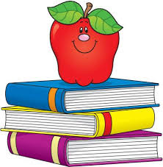

Over 3000 books on sale in school

You can pay by cash, cheque or creditcard
For every book purchase the school will receive commission for new books for our library. Thank you for your Support

