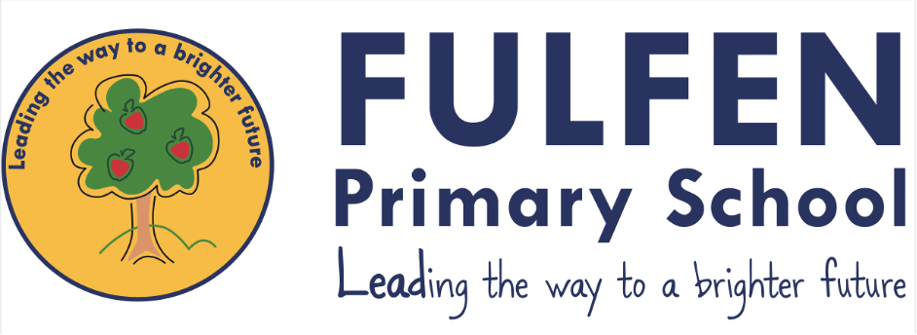

At Fulfen Primary School, we want to make sure that you feel looked after, safe and happy when you are in and out of school. Sometimes we don’t know if something bad is happening, so you need to tell us.

This policy looks at child-on-child abuse and bullying, and what you can do when you feel you are being abused or bullied, or when you notice someone else being abused or bullied.

We can help you by:

* Teaching you what child-on-child abuse is.
* Teaching you what to do if you feel like you are being abused, or if someone else is being abused.
* Making sure you know the grown-ups you can speak to if you are worried.

**Contents**

**1. What is child-on-child abuse?**

**2. Bullying**

**3. Sending inappropriate texts**

**4. Inappropriate touch**

**5. Relationships**

**6. How do I know if someone is being abused?**

**7. What should I do if I am being abused?**

**8. What should I do if someone else is being abused?**

**9. Who can I talk to?**

10. How can I help stop abuse from happening?

        

**TikTok Twitch**

**Twitter**

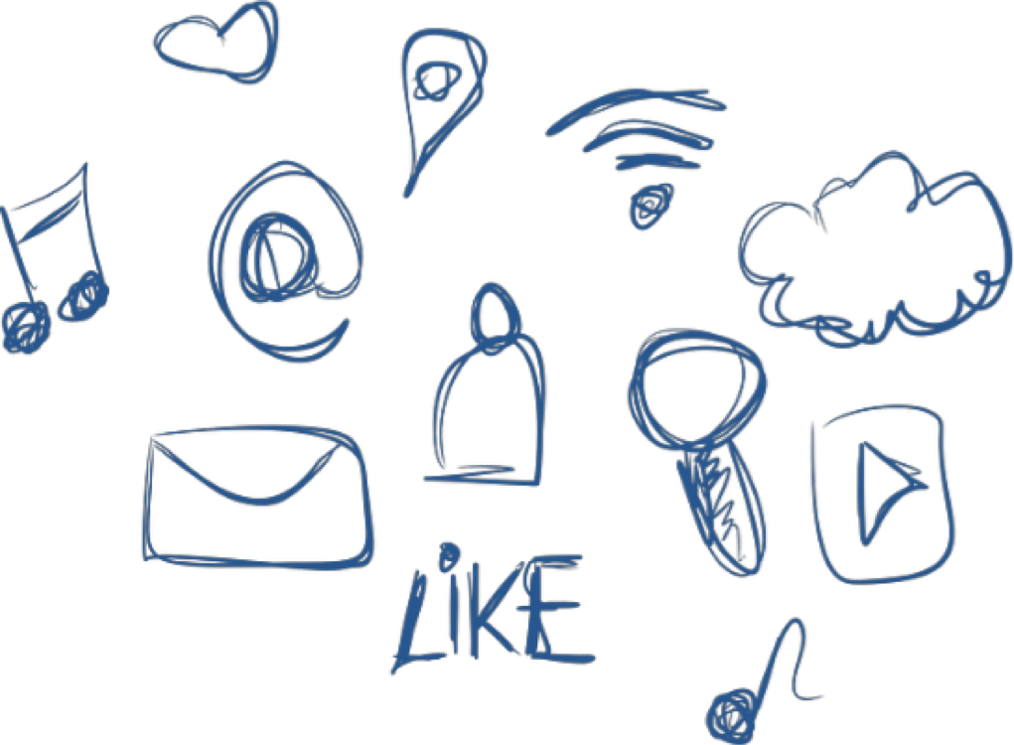

Whilst there are benefits to being online, there are risks too regardless

of your child’s age. Risks include your child viewing inappropriate content, sharing personal information, cyberbullying and grooming.

Child-Friendly Safeguarding and

Child on Child Abuse Policy

**Pupils at Fulfen need to feel SAFE and HAPPY at school.**



1. **What is child-on-child bullying and abuse**?

A **peer** is someone who might be your friend, a child at school with you or another child you may know.

**Abuse** is something which usually physically or emotionally **hurts** another person by using behaviour that is meant to **scare, hurt** or **upset** that person.

Sometimes, it can be hard to know when abuse is happening, because **not all** abuse will hurt,

scare, or upset you and you might not know it is happening. It’s really **important** you

know when you are being abused so we can make sure it stops.

There are lots of different types of abuse. It is important that you know what these

types of abuse are so you know what to do if you see them.

1. **Bullying**

Bullying can be different things, and isn’t just hitting or kicking another person.

**Emotional bullying** is hurting someone’s feelings, leaving them out or bossing them about.

**Physical bullying**, is punching, kicking, spitting, hitting or pushing someone.

**Verbal bullying** is teasing someone, calling them names or using rude hand signs. People can also use verbal bullying to be **racist** or **homophobic.**

**Racist** means bullying someone because of their skin colour, race or what they believe in.

**Homophobic** means bullying someone because of their gender or sexuality; calling someone gay or lesbian to hurt their feelings would be homophobic.

**Sexist** means bullying because of their sex (whether they are a boy or a girl).

**Cyber bullying** involves sending horrid messages over the internet or by text message. Bullying can be done through **another person**, by one person sending another person nasty things.

1. **Sending inappropriate messages**

This is sending inappropriate pictures, videos or messages – they can sometimes be called ‘nude pics’, ‘rude pics’ or ‘nude selfies’, but can also be rude messages. Pressuring someone into sending these pictures, videos and messages is abuse.

Even if you are not the person who is sending them, it is **illegal** to have these kinds of pictures or videos of a person if they are under 18 years old.

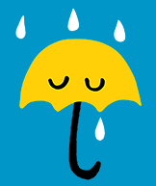

pasted-image.tiff

**4. Inappropriate touch**

It is not okay for someone to touch you in a way that makes you feel uncomfortable. Sometimes people can do things like this and lie and tell you things to frighten you and make sure you don’t tell anyone. You must tell someone at school or at home so that you will be taken care of and supported.

**5. Relationships**

Any relationship you have should be **good** and **happy.**

A bad relationship might make someone feel scared, confused, worried and even unsafe.

It’s really important that you know the difference between a good relationship and a bad relationship.

**Good relationships**

* You are **comfortable** around that person.
* You can be **honest** with that person.
* You can say how you **feel,** what you are **thinking** and **listen** to each other.
* You **support** each other and treat each other nicely.
* You feel **safe.**
* You **trust** that person.
* You are **equal**- you don’t boss each other around or tell each other what to do.
* You feel **looked after.**

**Bad Relationships**

* The person might **push** you, **hit** you or **destroy** your things.
* The person might **tell you what to do**, what to wear or who you can see.
* You might feel **scared** – they might say they will hurt you if you don’t do something.
* They might also say they will hurt you if you do something too.
* The person **calls you names**, makes you feel bad in front of other people and

makes you **feel bad about yourself.**

* The person gets **angry easily** and you don’t know what will make them angry –

it might make you feel **nervous.**

* The person might not **take no for an answer** when you say you don’t want to do something.

**6. How do I know if someone is being abused?**

It might be hard for you to know if you are being abused and you **might not really** **understand** it is happening. It is important you can **recognise** when behaviour isn’t appropriate.

It’s also important that you can notice when someone else might be being abused.

Some signs might be:

* Not going to school.
* Having injuries, like bruises.
* Feeling sad and down.
* Feeling they can’t cope.
* Feeling withdrawn or shy.
* Getting headaches or stomach ache.
* Feeling nervous.
* Being abusive to someone else.
* Not being able to sleep/having nightmares
* Feeling panicked.

**7. What do I do if someone else is being abused?**

If you see someone else being abused, it is important that you **help** that person.

You should **never walk away** and ignore the problem if you see someone else being abused, because the person might keep upsetting them.

If you can, and it is **safe** to do so, tell the person abusing you to **stop**, but never get angry or hit them.

Tell a grown up, such as a trusted adult in school, as soon as you have seen someone being abused.

Grown-ups can **stop the abuse** and make that person feel happy again.

You should **never feel scared** to tell someone about abuse.

Sometimes, you might not see someone being abused, but you might be worried about them. Or, you might think they are being abused by someone you don’t know, or someone they have told you about. It’s really important you tell someone even if you are worried, but haven’t seen any abuse.

**8. What to do if I am being abused?**

The first thing you should do is tell **someone you trust**. This could be a family member, a friend or any **adult in our school**.

You can tell the **person abusing you** to leave you alone. If telling them to leave you alone would **make you feel too scared or worried** **that they might hurt you**, make sure you tell someone so they can help.

You should **try not** to:

* **Do** what the person says.
* Let what the person says or does **upset** you.
* Get **angry** or hit them.

Always remember that if you are being abused, it is **not your fault** and you are **never alone**. You shouldn’t be scared to **talk to someone** if you are being abused. If you talk to a grown up, **we can make the abuse stop.**

**9. Who can I talk to?**

It is important to **tell someone** as soon as you are being abused., or notice someone being abused.

Speak to someone like your Mum, Dad, Carer, Nan, Grandad or a trusted adult in school will mean we can make sure that the abuse stops and doesn’t happen again.

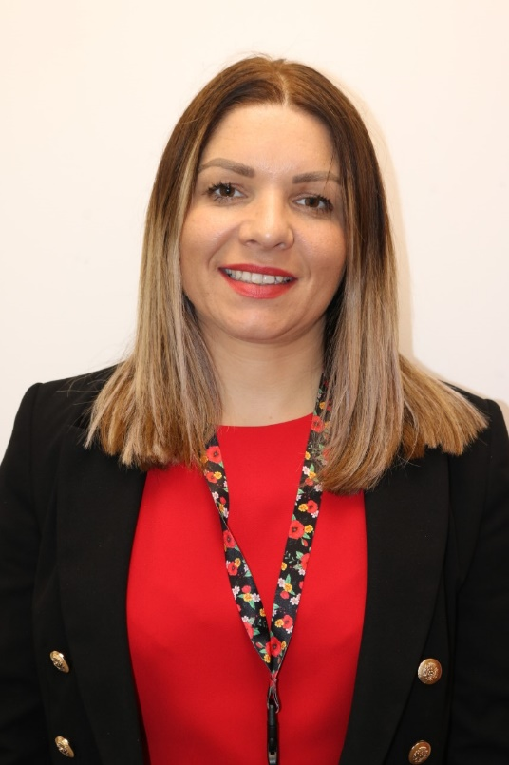Mrs Tranter is the Designated Safeguarding Lead

Miss Davies is the Deputy Designated Safeguarding Lead

 Miss Haig Safeguarding and Wellbeing Officer

pasted-image.tiff

**10. How can I help stop abuse from happening?**

We can all help stop abuse at our school by:

* Making sure we understand how we should act towards others.
* Helping others when they are in need.
* Being kind, friendly and respectful to others.
* Thinking about other people’s feelings before we say or something.
* Taking part in school activities, like assemblies and PSHE lessons which talk about child on child abuse.
* Talking to someone when we are worried.

**You should know that abuse is never OK and it is serious, it is not funny, or part of growing up. If you abuse someone, you will get into trouble.**

