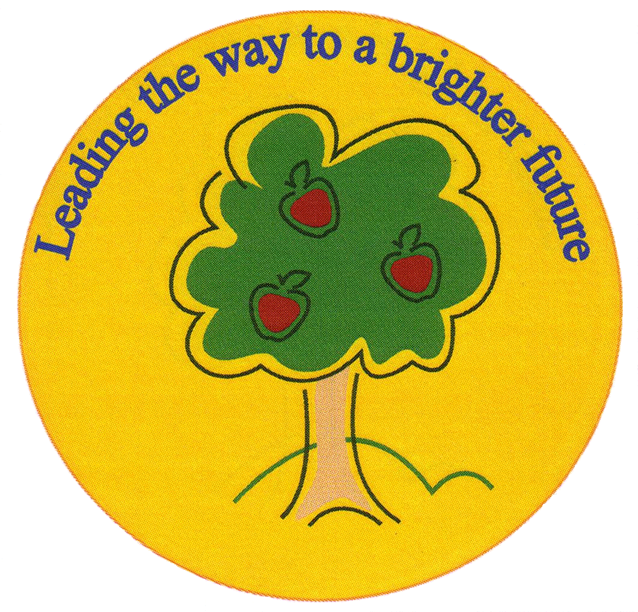
Fulfen Primary School

Rugeley Road
BURNTWOOD
Staffordshire
WS7 9BJ

Telephone: 01543 226070
E-mail: Office@fulfen.staffs.sch.uk

Headteacher: Miss Jane Davies

19/05/20

RE: Arrangements for increased numbers of pupils from June 1st 2020.

Dear Parents and Carers

I would like to begin by offering a huge ‘thank you’ for supporting the school over recent weeks and for supporting your child with their home learning.

As you will be aware, the government has announced that so long as they are satisfied that it will be safe enough to do so schools will reopen from 1st June 2020 for:
- Nursery
- Reception
- Year 1
- Year 6
Schools will also continue to be open for:
- Children of key workers
- Vulnerable pupils: those with an EHCP, with a Social Worker, or those with vulnerability to whom the school have decided to offer a childcare place.
The scientific evidence will be reviewed this week by the Government and after this time we expect further clarification around the partial re-opening of schools on the 1st June. In order to prepare for this, the SLT have produced a plan for reopening which is set out in the letter below.

Thank you for informing us of your decision of whether or not your child/children will be attending Fulfen from 1st June. We have now allocated your child/children to a team of staff who will support your child/children socially, emotionally and educationally. This has taken a considerable amount of time to coordinate and it would therefore be impossible for a parent to change their mind and expect a place in school immediately for their child/children. We would ask parents that if circumstances change and they now wish for their child to attend school, they need to inform us of this change as soon as possible. We would then allocate them a place at the next review meeting. These review meetings will take place every two weeks.

We are very much looking forward to seeing many of our children once again, but I would like to reassure you that the safety of our school community is our priority.

I am therefore writing to share with you the arrangements we have implemented to reduce risk for staff, pupils and parents. These arrangements have been put into place following a full risk assessment process and are in line with guidance from the Department for Education.

We will continue to review the arrangements we have implemented and update you with any changes as and when we make them.

We recognise that some of you may have some concerns about your child returning to school and that for some children another change will be unsettling for them. We also understand that the past weeks will have been challenging for many families. If you would like to talk to us about your child and any concerns you have about their return to school, please – in the first instance – contact the Deputy Head - Mrs Tranter (senco@fulfen.staffs.sch.uk). If your child has an EHC plan please contact Mrs Tranter, who will support you and your child with their return to school.

School staff:
- Year 6: Mr Wood, Miss Gardner, Miss Green and Mr Morton
- Year 1: Miss Marriott, Mrs Barber, Mr Simkins, Mrs Kilgallen, Mrs Turton, Miss Atkinson, Miss Jones and Mrs Moore
- Reception: Miss Pretty, Mrs Russ, Mrs Carter, Mrs Bayley, Mrs Aplin, Mrs Owen and Mrs Willows
- Nursery: Miss Hughes, Miss Simkins, Mrs Rogers, Mrs Harrison, Miss George
- Key worker and vulnerable pupils (years 2, 3, 4 and 5): Miss Greenfield, Mrs Shokar, Miss Walters, Miss Holloway, Miss Morgan, Mrs Pendleton, Mrs Evans, Mrs Shermer, Miss Westwood, Miss McCappin, Mrs Ashcroft, Mr Gleeson, Mr Chapman, Mrs Connock and Mrs Jackson

Maintaining a safe school environment

I would like to take this opportunity to remind you of the preventative measures the school has put in place in order to minimise the spread of infection.

As per the advice from the government, the following actions for infection control remain in place:
- Displaying coronavirus infection control measures information posters around the school
- Encouraging good hygiene by promoting the importance of handwashing for at least 20 seconds with warm water and soap in the following circumstances:
  - Before leaving home
  - On arrival at school
  - After using the toilet
  - After breaks and sporting activities
  - Before food preparation
  - Before eating any food, including snacks
  - Before leaving school
  - At regular intervals throughout the day
- Ensuring pupils and staff understand that they must cover their cough or sneeze with a tissue, then throw the tissue away
- Ensuring frequently touched objects and surfaces are cleaned and disinfected more regularly than usual
- Calling NHS 111 if someone becomes unwell, isolating any unwell people in a separate room, and providing a separate bathroom, where possible
- Telling staff to stay at home for seven days if they develop symptoms of coronavirus
- Providing staff training on PPE, rubbish disposal, mental health and well-being
As an important part of our school community, I would ask that you continue to encourage good infection control practices, such as thorough handwashing, at home and keep your child informed about the things they can do to discourage the spread of infection.

In line with the current NHS and government advice, you should keep your child at home if they develop coronavirus symptoms for a period of seven days. Symptoms include a high temperature or a new, continuous cough. Where symptoms continue after seven days, or begin to worsen, you should call 111. If someone in your child’s household has symptoms, your child must self-isolate for 14 days from the day the other person’s symptoms started. This is because it can take 14 days for symptoms to appear. More information regarding symptoms and actions can be found on the NHS website (https://www.nhs.uk/conditions/coronavirus-covid-19/).

If you think your child may have been exposed to or has coronavirus, or if your child receives a positive test result for coronavirus, please contact the school on 01543 226070 at the earliest opportunity.

Arrangements for the start and end of the school day

The beginning and end of the school day are the busiest times for children and adults congregating together in one place and maintaining safe distances within normal arrangements can be a challenge. We have implemented the following measures for when pupils return to school:

Procedures for dropping off and picking up children:

- Year 6: 8:30 a.m. – 2:45 p.m. (stand on the KS2 playground and the children may enter and exit via Miss Gardner’s side classroom door)
- Year 1: 9:00 a.m. – 3:00 p.m. (Stand on KS1 playground and the children may enter and exit via Miss Marriott’s side entrance door)
- Reception: 9:15 a.m. – 3:15 p.m. (Stand on Reception playground and the children enter via Reception classroom entrance door)
- Nursery: 9:30 a.m. – 11:30 a.m. – morning session
1:40 p.m. – 3:40 p.m. – afternoon session
9:30 a.m. – 3:40 p.m. – all day
(Pre-school classroom entrance door)
(Nursery 2’s – enter via Mini Adventurers entrance (formerly Little Owl Childcare)
- Key worker and vulnerable pupils (years 2, 3, 4 and 5): 8:45 a.m. – 3:30 p.m. (KS1 entrance door)
(If you have children in more than one class, please bring and collect all your children at the later time)

- We would kindly ask parents to adhere to the times allocated above to drop off and pick up their children from school
- There will be a one way system in place for parents
- There will be spots placed 2m apart for parents to stand on when waiting in the playground
- We would ask that only one adult drops off and collects children

Arrangements for break times and lunchtimes

We recognise the importance for all pupils to have a break from learning and to enjoy time outside during the school day. Reconnecting with friends will be an important aspect of pupils settling back into school life, but we have made some adjustments to break and lunch times.

- At break times, the children will go out with their own class group at an allocated time. Their group will play together in a section of the playground
- Lunchtimes will be staggered for different year groups:
- Nursery – 11:45 a.m. – 12:45 p.m.
- Reception - 12:45 a.m. – 1:45 p.m.
- Year 1 – 12:00 noon – 1:00 p.m.
- Key Worker and Vulnerable children (year 2, 3, 4, and 5) – 12:15 p.m. – 1:15 p.m.
- Year 6 – 12:30 p.m. – 1:30 p.m.
- Nursey and Reception pupils will eat their lunch in the hall at their allocated time
- Year 1, Key worker and Vulnerable pupils and Year 6 will collect their lunch (either from the canteen or packed lunch and eat in their class
- Pupils will then be taken outside to play in their part of the playground
- Children will be encouraged to play games where social distancing can be observed. Contact sports such as football or tag rugby will not be allowed.

The school day

To minimise the number of pupils and staff assembling for periods of time, we have made the following changes to the school day:

- We have arranged classrooms so that social distancing can be observed, as far as possible.
- Obviously, as stated in the government guidelines, social distancing will not be possible with the younger children in nursery and reception
- Children will be kept in ‘bubbles’ and will remain in these ‘bubbles’ for the whole of the school day.
- Assemblies will take place in the classroom with the class by the teacher
- The curriculum will be delivered as normal (as far as possible)
- Marking will be done with the children as far as possible and within the school day. Books will not be taken home by the teachers
- P.E. will have guidelines to adhere to and contact sports will not be allowed
- Children will be taken outside to learn, wherever possible
- PPE will not be worn by staff other than when delivering first aid and intimate care for early years pupils.
- Pupils are asked not to wear school uniform and come to school suitably dressed for outside activities.
School Communication

If you wish to communicate with the school, please can you email (office@fulfen.staffs.sch.uk) or phone the office (01543 226070). Parents will not be allowed to access the school building. The office will be closed to visitors and parents.

School Trips and events

- There will be no school trips or events taking place in the foreseeable future. This will be reviewed as the situation changes.

Transition from Year 6 to Year 7

We recognise that this is a really important time for our Year 6 pupils as they are preparing for secondary school in September. Whilst we will not be conducting any on-site visits to secondary schools, we will still be doing everything that we can to support these pupils to be ready. This includes:
- Liaising closely with our secondary schools to make sure they know all of the important information about your child.
- Providing bespoke lessons and guidance for year 6 pupils about transferring to secondary school.
We will answer any questions that they have and support them with any anxieties so that they can make the best possible start.

Support for pupils and families

We do not underestimate how difficult the recent weeks have been for us all and we all will have been touched in some way by the coronavirus pandemic. We recognise the need to focus on pupils’ emotional wellbeing as well as their return to learning. The following support is in place for pupils once they return to school.

- The class teacher and support staff will deliver regular personal, social and emotional support to pupils
- Mrs Tranter will oversee any referrals that need to be made

Parents may wish to seek support for themselves from the following support agencies:

- Samaritans – call free 24 hours a day on 116 123
- National Domestic Abuse Helpline – call for free and confidential advice, 24 hours a day on 0808 2000 247
- Shelter provide free confidential information, support and legal advice on all housing and homelessness issues if you call 0330 0536 083 (please note, this is not a free phone number and your call will be charged). A free webchat is available at https://england.shelter.org.uk/get_help/webchat

I hope that these arrangements provide you with the information you need to support your child to return to school.

Yours sincerely,

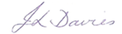

Miss Davies

