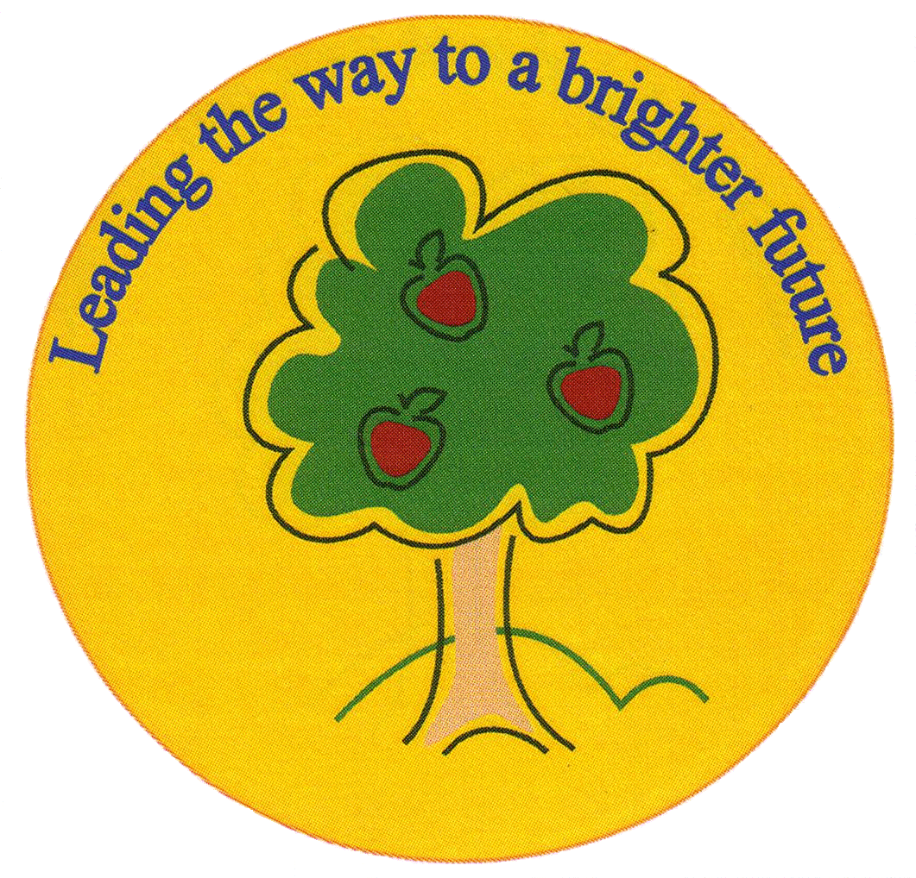
Fulfen Primary School

Rugeley Road
BURNTWOOD
Staffordshire
WS7 9BJ

Telephone: 01543 226070
E-mail: Office @fulfen.staffs.sch.uk

Headteacher: Miss Jane Davies

Dear Parents/Carers,

Our current topic is learning about the history of local people. To bring this topic alive and give the children a true hands-on experience, we are going on a school trip to Lichfield on Monday 10th February. Whilst there, we will be visiting the Birthplace of Samuel Johnson, where the children will get to dress up and rein-act the story of Samuel Johnson’s life. They will also get the opportunity to see the dictionary that was written by him and discover more about his life. In addition to this visit, we will go to Erasmus Darwin’s house, where the children will be able to investigate and handle several historical artefacts and begin to understand what it was like to live in the 18th century. We will also be going on a short walk around the historic centre of Lichfield.

Learning about important people from our locality is a vital part of the history curriculum and this trip will enhance the activities we carry out in school. It is a unique experience, only offered to school visits. We are extremely excited to offer this combination of History, Science and English in two different historic houses.
The children will need to wear their school uniform with sensible shoes for this trip and bring a packed lunch and a drink.

The cost of this trip is only £12; please pay on Parentpay. The price includes the cost of the coach and 2 expert led workshops. If we don’t receive sufficient funds the trip may have to be cancelled. If your child will require a packed lunch provided by school, can you please make this clear on your reply slip and return it by Monday 3rd February.

Thank you,

Miss Greenfield and Miss Ryan

Year 2 Trip to Lichfield

Name of child: ____________________________ Class_____________

I give permission for my child to attend the trip to Lichfield on Monday 10th February. I have paid a contribution of £12.00 on Parentpay.

I will require a packed lunch from school for my child
(in which case, please return slip by the 3rd February in order for the kitchen to order food)

Signed: __________________________ (person with parental responsibility)

