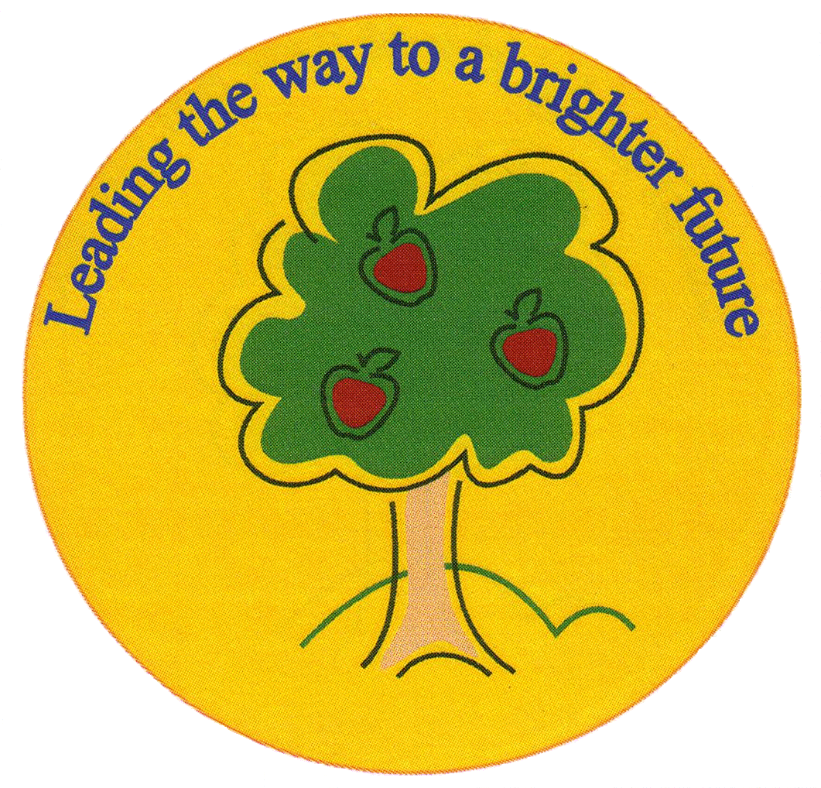
Fulfen Primary School

Rugeley Road
BURNTWOOD
Staffordshire
WS7 9BJ

Telephone: 01543 226070
E-mail: Office @fulfen.staffs.sch.uk

Headteacher: Miss Jane Davies

Dear Parents/Carers,

On Wednesday 21st November 2018, Year 6 will be visiting Birmingham Central Mosque as part of our topic on Ancient Islamic civilisation. This visit will offer the children a fantastic opportunity to see first-hand the structures & features of a mosque as well as the daily worship practised by Muslims.

We will be leaving school at 9.15am to arrive at the mosque at approximately 10.00am. We will be given a guided tour during which the children will be allowed to ask questions and observe a special prayer service.

Children will wear their normal school uniform and will need to bring a packed lunch with them as we may not be back in time for school dinners. Children will be back at school before the end of the school day and can be collected at the normal time.

A voluntary contribution of £6.00 towards the cost of this visit would be appreciated. Please can you fill in the consent form and pay for the trip on Parent Pay before Wednesday 14th November.

Thank you

Miss Greenfield & Mr Mennell
……………………………………………………………………………………………………………………………………………………………………………………
Visit to Birmingham Central Mosque

I give permission for my child……………………………………………………………………………… Class…………………..
To participate in the trip to Birmingham Central Mosque on Wednesday 21st^{h} November 2018.

I have paid £………………………… Voluntary contribution on Parent pay

Signed……………………………………………………………………………… Parent/Carer

