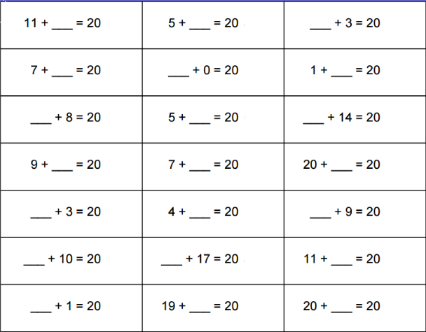

Name:

Speed Challenge!

Number pairs to 20.

How fast can you answer these questions?

Get someone to time you!